2022 PROGRESS REPORT

Quarter: (circle one) 2022 1st 2022 2nd 2022 3rd 2022 4th

Grant Program, Number and Title: Wildlife Management Institute, Grant # 5060049FF, Spatial Structure and Genetic Connectivity in the spotted turtle.

Organization: Virginia Commonwealth University

Project Leader: Dr. Rodney Dyer

Abstract: The objectives of this project are focused on analyzing the spatial genetic structure of spotted turtle populations from throughout the species range. We have now been given all the samples for processing for 2021 & 2022 and are in the process of getting genotypes sequenced and analyzing existing spatial genetic structure.

Were planned goals/objectives achieved last quarter? This third quarter required us to recreate the libraries that failed sequencing in the second quarter and send them off again for sequencing. We anticipate that the data should be back to us and we can begin analysis of the data, despite the setback in the previous quarter.

Progress Achieved: We were able to get the samples reconfigured and sent off to the sequencing facility in a timely fashion.

Difficulties Encountered: As a precautionary measure, I requested that they sequence the first library (500 individuals) and wait to make sure it is successful before sequencing the remaining 2 libraries (1000 individuals containing this and the confiscated samples). The first sequencing was very successful and we received a good amount of sequencing content to move forward.

On 22 September, I requested that the facility proceed to sequence the remaining 1000 individuals to complete the process. The next week, I received an email from the facility saying that they had ‘accidentally discarded’ the remaining samples and could not proceed with the sequencing (email pasted below).

This required that we initiate the process of recreating the libraries for the last 1000 individuals for the third time. This is the first time that I’ve had these challenges with a sequencing facility, who have previously been able quickly and efficiently process our samples without problem or delays.

So, we were planning on having all the samples sequenced and analyses began this quarter and we are back at the start again. We are working to resubmit these samples again.

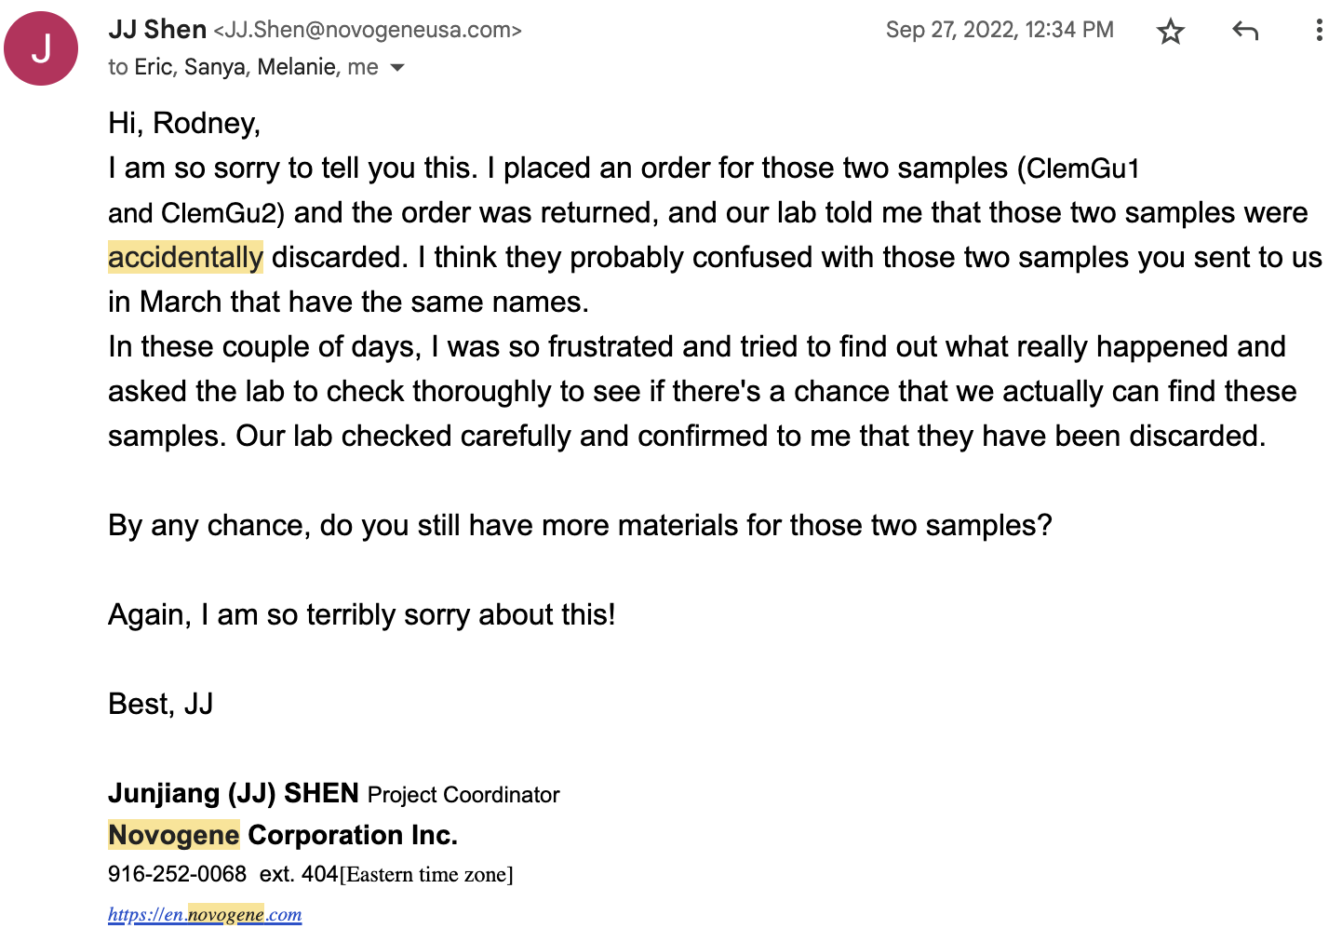

Activities Anticipated Next Quarter: Receive sequences and perform analyses.

Expected End Date: This project was expected to finish by the end of 2022, though continued setbacks from the sequencing process have caused concerns. Hopefully, we can get the samples back in a timely manner.

Costs:

Total life-to-date expenses (including this quarter): $ 63,111.13

Total Approved Budgeted Funds: $ 17,434.41

Are you within the approved budget plan and categories? Yes

Signature

