2022 PROGRESS REPORT

Quarter: (circle one) 2022 1st 2022 2nd 2022 3rd 2022 4th

Grant Program, Number and Title: Wildlife Management Institute, Grant # 5060049FF, Spatial Structure and Genetic Connectivity in the spotted turtle.

Organization: Virginia Commonwealth University

Project Leader: Dr. Rodney Dyer

Abstract: The objectives of this project are focused on analyzing the spatial genetic structure of spotted turtle populations from throughout the species range. We have now been given all the samples for processing for 2021 & 2022 and are in the process getting genotypes seqeunced.

Were planned goals/objectives achieved last quarter? The sequencing attempt in the first quarter did not work properly and both lanes returned a few gigabytes of unusable data. It is not clear if the issue was with the sequencing center or the reagents we have been using. We remade the libraries for the previous two lanes and were able to add the second year’s samples to create additional libraries. We’ve QA/QC’d things twice on our end and sent off the combined set of samples to the sequencing facility again.

Progress Achieved: We recreated the libraries, ran everything through QA/QC twice, and sent off raw templates for sequencing.

Difficulties Encountered: Slowness in sequencing seems to continue to be a problem but not as much of an issue as no usable sequences in our first two lanes. We replaced all reagents, and remade the libraries to be sent off again.

Activities Anticipated Next Quarter: Receive sequences and perform analyses.

Expected End Date: This project is expected to finish by the end of 2022.

Costs:

Total life to date expenses (include this quarter): $ 45,676.72

Total Approved Budgeted Funds: $ 16,846.30

Are you within the approved budget plan and categories? Yes

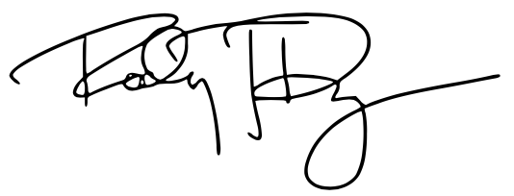

Signature:

Date: 28 July 2022

