2022 PROGRESS REPORT

Quarter: (circle one) 2022 1st 2022 2nd 2022 3rd 2022 4th

Grant Program, Number and Title: Wildlife Management Institute, Grant # 5060049FF, Spatial Structure and Genetic Connectivity in the spotted turtle.

Organization: Virginia Commonwealth University

Project Leader: Dr. Rodney Dyer

Abstract: The objectives of this project are focused on analyzing the spatial genetic structure of spotted turtle populations from throughout the species range. We have now been given all the samples for processing for 2021 & 2022 and are in the process getting the first set of samples sent off for sequencing for post sequencing analyses.

Were planned goals/objectives achieved last quarter? This last quarter we completed processing the first batch of samples, created the libraries and sent off samples to the sequencing center.

Progress Achieved: We processed the first batch of samples, created libraries and sent off to be sequenced.

Difficulties Encountered: Slowness in the ability to get any genetic sequencing has caused significant delays. Right now, there is a severe backup on genetic sequencing services and smaller, non-medical projects like this one seem to be pushed to the background.

Activities Anticipated Next Quarter: In the second quarter of 2022, we will extract DNA from the remaining samples and get those sent off as well.

Expected End Date: This project is expected to finish by the end of 2022.

Costs:

Total life to date expenses (include this quarter): $ 38,261.87

Total Approved Budgeted Funds: $ 24,076.13

Are you within the approved budget plan and categories? Yes

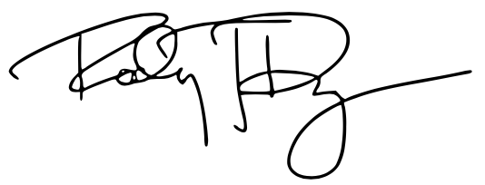

Signature:

Date: 10 April 2022

