2021 PROGRESS REPORT

Quarter: (circle one) 2021 1st 2021 2nd 2021 3rd 2021 4th

Grant Program, Number and Title: Wildlife Management Institute, Grant # 5060049FF, Spatial Structure and Genetic Connectivity in the spotted turtle.

Organization: Virginia Commonwealth University

Project Leader: Dr. Rodney Dyer

Abstract: The objectives of this project are focused on analyzing the spatial genetic structure of spotted turtle populations from throughout the species range. We have now been given all the samples for processing for 2021 and are in the process of extracting DNA, creating sequencing libraries, and conducting QA/QC for genetic analyses.

Were planned goals/objectives achieved last quarter? This last quarter we continued to process samples as they were sent to us for next year's analysis and to develop the genomic libraries to send off for sequencing. During the fourth quarter, we have made significant progress on DNA extraction and QA/QC of templates in preparation for sequencing. We now have in excess of 1500 samples collected and DNA extracted.

Progress Achieved: We have finished extracting DNA for all samples for the first round of funding and are almost finished preparing the libraries for sequencing.

Difficulties Encountered: No difficulties were encountered.

Activities Anticipated Next Quarter: In the first quarter of 2022, we will extract the second round of samples and provide the results of sequencing to the funding agency for the first round of genomic sequences.

Expected End Date: This project is expected to finish by the end of 2022.

Costs:

Total life to date expenses (include this quarter): $ 29,199.49

Total Approved Budgeted Funds: $ 33,138.51

Are you within the approved budget plan and categories? Yes

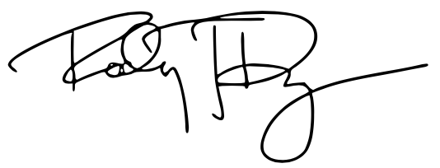

Signature:

Date: 10 February 2022

