2021 PROGRESS REPORT

Quarter: (circle one) 2021 1st 2021 2nd 2021 3rd 2021 4th

Grant Program, Number and Title: Wildlife Management Institute, Grant # 5060049FF, Spatial Structure and Genetic Connectivity in the spotted turtle.

Organization: Virginia Commonwealth University

Project Leader: Dr. Rodney Dyer

Abstract: The objectives of this project are focused on analyzing the spatial genetic structure of spotted turtle populations from throughout the species range. We have now been given all the samples for processing for 2021 and are in the process of extracting DNA, creating sequencing libraries, and conducting QA/QC for genetic analyses. We are slated to have results by the end of year and will be submitting all the samples for sequencing in late October.

Were planned goals/objectives achieved last quarter? This last quarter we continued to process samples as they were sent to us for next year's analysis. During the third quarter, we have made significant progress on DNA extraction and QA/QC of templates in preparation for sequencing. We now have in excess of 1500 samples collected and DNA extracted.

Progress Achieved: We have finished collection and pre-processing of DNA samples and have extracted all tissues provided for this years analyses. We are in the process of creating DNA libraries and sequencing products.

Difficulties Encountered: No difficulties were encountered.

Activities Anticipated Next Quarter: In final quarter 2021, we send off samples for sequencing and conduct analyses commensurate with the final project requirements—quantifying diversity and structure from populations throughout the eastern portion of the species range.

Expected End Date: This project is expected to finish up by the end of 2022.

Costs:

Total life to date expenses (include this quarter): $ 18,880.86

Total Approved Budgeted Funds: $ 43457.14

Are you within the approved budget plan and categories? Yes

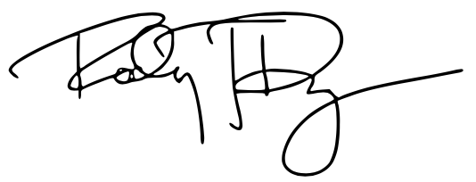

Signature:

Date: 4 October 2021

