FINAL REPORT for GSA #00074

Grant Program, Number and Title: GSA 00074 - Conservation Plan for the Blanding’s Turtle and associated Species of Conservation Need in the Northeastern United States

Organization: The Orianne Society

Project Leader: Kiley Briggs

Grant Term: July 1, 2019 through June 30, 2022

Objectives: The primary objectives of this project were to advance conservation efforts for Blanding’s Turtles in the northeast by working with state biologists to:

- Identify and facilitate action on site specific conservation needs at select sites within the Blanding’s Turtle Conservation Area Network,
- Develop and distribute outreach materials about Blanding’s Turtle Best Management Practices (BMPs),
- Help format and contribute to a site action tracking database,
- Develop or update site-specific conservation plans for selected sites, and
- Participate in monthly conference calls with the Northeast Blanding’s Turtle Working Group and other discussions with state biologists, conservation groups, and other stakeholders.

Ultimately, progress made through this sub-award is intended to expand the capacity of the Northeast Blanding’s Turtle Working Group to secure funds for regional Blanding’s Turtle conservation efforts.

Accomplishments:
Facilitating conservation action was customized for each state, however all actions fell into one of several broad categories; conservation partner engagement, land protection planning, nest site management and monitoring, roadkill mitigation, landowner outreach, and trapping assessments.

Partner Outreach: During the project, 29 state, federal, and non-profit partners were engaged in Blanding’s Turtle conservation planning, including six land trusts, two public schools, eight municipal conservation commissions, one university, four non-profit conservation organizations (apart from land trusts), five state wildlife agencies, the United States Forest Service, the Natural Resources Conservation Service, the United States Fish and Wildlife Service, and the United States Department of Defense.

Several of these entities had no prior history of Blanding’s Turtle involvement, and in several cases, non-profit organization and town conservation commissions were reinvigorated to continue or expand conservation efforts for the species.

Land Protection Planning: We worked with state biologists in Maine to identify parcels where land protection is the highest priority, which led to landowner outreach and the formation of a land protection subcommittee. We also produced parcel maps, identified landowners, and obtained landowner contact information for two sites in New York where large scale nest site creation projects may be implemented contingent on funding. For each selected site, we also produced maps showing the highest priority parcels for protection and acquisition.

Nest Site Management and Monitoring: Planning sessions with MassWildlife resulted in five nest sites being scarified to improve nesting habitat, each of which we monitored for nesting activity using game cameras. Additionally, we helped advance discussions between state biologists and several town conservation commissions where nest site enhancements on town land are high priorities. In New Hampshire we deployed game cameras at 10 recently constructed nesting mounds to monitor turtle activity on private land and initiated meetings between New Hampshire Fish and Game and a local school board to find opportunities for habitat enhancement on a school-owned property. At a site in New York with no history of past Blanding’s Turtle management and no obvious quality nesting habitat, we identified two potential locations on conserved lands where large scale nest sites may be constructed in the future. At another site in New York, we identified ways to improve the sustainability of nest protection efforts through the use of electric fencing. Our efforts through this grant will result in additional nest site monitoring, enhancement, and creation through renewed collaboration between state agencies and municipal partners.

Roadkill Mitigation: Nest site management outlined above has the secondary benefit of reducing roadkill by providing nesting habitat away from roads. We also organized a volunteer work day to patch fencing along a major state highway where roadkill likely poses the greatest threat to the resident Blanding’s Turtle population. Additionally, we gave an introductory presentation to a town conservation commission in New Hampshire regarding culverts that exacerbate the roadkill risk.

Private Landowner Outreach: We assisted biologists in New York in obtaining landowner contact information in areas where land protection and nest site creation are needed. In Maine, land protection planning sessions resulted in a ranked list of priority parcels for conservation, and the owner of the highest priority parcel has since been contacted by Maine Department of Inland Fisheries and Wildlife.

Trapping Assessments: In New Hampshire we conducted one rapid trapping assessment to collect preliminary Blanding’s Turtle data on private land adjacent to a state park.

To disseminate information about Blanding’s Turtle BMPs we used information from technical BMPs documents to create a brochure and booklet outlining BMPs for different target audiences (Appendix 1). While the technical documents are ideal for use by state agencies and herpetologists, the brochure we developed is geared toward landowners who have expressed an interest in Blanding’s Turtle conservation. The BMPs booklet is intended for use by land stewards such as land trusts, other non-profits, consulting foresters, etc. We printed 1,000 brochures and 250 booklets, which were distributed evenly to state wildlife agencies in New York, Massachusetts, New Hampshire, and Maine, with a smaller number distributed to Pennsylvania.

A contractor working under a different sub-award took the lead in developing a conservation action tracking database for use at Wood Turtle sites. To avoid duplication of efforts, rather than develop our own action tracking database for Blanding’s Turtles, we reviewed the Wood Turtle database being developed and provided feedback on how to adapt it for use with Blanding’s Turtles. We tracked conservation and outreach actions at selected sites using a spreadsheet that will be uploaded into the Blanding’s Turtle database as soon as it is ready for use.

Site Conservation Plans were updated for 11 high priority sites within the Blanding’s Turtle Conservation Area and two new plans were written for sites where plans were lacking. These plans all provide an overview of past conservation actions at each site and outline basic information about Blanding’s Turtle survey effort, demographics, known and presumed site-specific threats, as well as the top priorities for land protection and conservation actions.

Through the grant period, we were in close communication with the Northeast Blanding’s Turtle Working Group, participating in 30 monthly conference calls and organizing over 20 state or site-specific meetings and planning sessions. Ultimately, our efforts over the past few years put state agencies and the Northeast Blanding’s Turtle Working Group in a good position to obtain funding for boots-on-the-ground conservation actions, potentially through a Competitive State Wildlife Grant (CSWG) or other funding sources as early as 2023.

Were planned goals/objectives achieved? Yes

Progress Achieved:

- Identify and facilitate action on site specific conservation needs
  - Nest site management and monitoring in MA and NH,
  - Outreach to at least 29 conservation partners in MA, NH, NY, and ME,
  - Landowner outreach in ME and NY,
  - Over 20 meetings with state biologists and other stakeholders in MA, NH, NY, ME, and PA,
  - Formation of a land protection subcommittee in ME,
  - Priority parcel identification in MA, NH, NY, ME, and PA,
  - Facilitated nest site management in MA and NH, future nest site creation in NY, and possible changes to nest protection strategies at one site in NY,
  - Nest site monitoring in MA and NH,
  - Organized volunteer work day in MA to patch fencing designed to keep turtles off a major state highway, and
  - Conducted a rapid trapping assessment at a data-deficient site in NH.

- BMP dissemination
  - Reviewed literature to consolidate Blanding’s Turtle BMPs into concise, jargon free documents,
  - Designed, printed and distributed 1,000 BMP brochures for landowners to each state, and
  - Designed, printed, and distributed 250 BMP booklets for conservation biologists and other land stewards to each state.
- Action Tracking Database
  - Provided feedback on an action tracking database in development for Wood Turtle sites so it can easily be adapted for use with Blanding’s Turtles, and
  - Tracked actions at selected sites in spreadsheets for easy upload to the action tracking database as soon as it is ready for use.
- Conservation Plans at Selected Sites
  - Updated 11 site conservation plans, and
  - Drafted two new site conservation plans for two sites in NY.
- Conference Calls and other Meetings
  - Participated in 30 monthly conference calls with the Northeast Blanding’s Turtle Working Group, and
  - Organized, led, or participated in at least 20 site-specific meetings to prioritize conservation actions and plan implementation strategies.
- Expand Fundraising Capacity of the Working Group
  - Discussed funding strategies to address site specific threats that might not fit into a regional funding proposal, and
  - Built support for a third CSWG proposal or other regional funding opportunities as soon as 2023, possibly in collaboration with the Spotted Turtle Working Group.
- Other
  - Wrote and submitted quarterly progress reports,
  - Tracked hours and expenses for invoices, and
  - Traveled to each of the selected sites at least once in 2021.

Difficulties Encountered: Travel disruptions in 2020 caused by the Covid-19 pandemic led to many site visits being deferred until 2021 and contributed to the need to amend the end date of the sub-award through a no-cost extension.

Costs:

Total life to date expenses (include this quarter): $50,000.00

Total Approved Budgeted Funds: $50,000.00

Are you within the approved budget plan and categories? Yes

Signature:

Date: August 13, 2022

Kiley Vincent Briggs
Director of Conservation, The Orianne Society
 | (802) 363-2494 | www.orianne.org | | kbriggs@oriannesociety.org

- Appendix 1 –

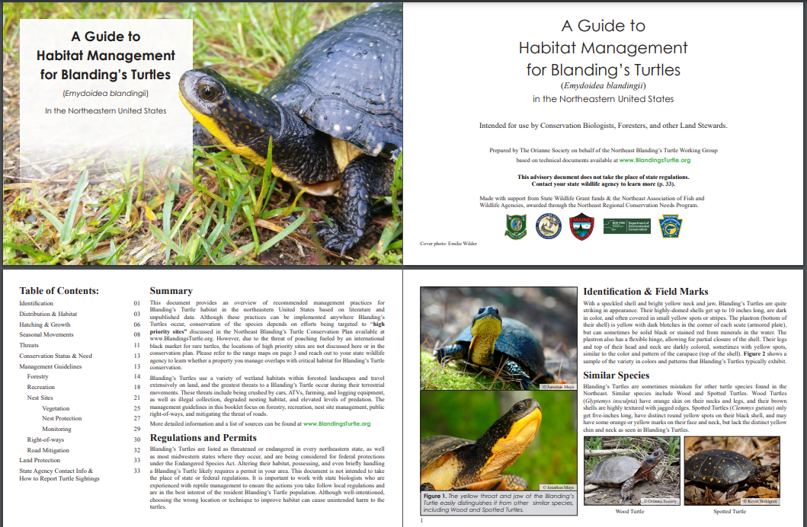
Figure 1. Cover and first few pages of a booklet outlining Best Management Practices for Blanding’s Turtle habitat management for use by conservation biologists, foresters, government agencies, and other land stewards. 250 physical copies were distributed to states and a PDF will be available at www.BlandingsTurtle.org
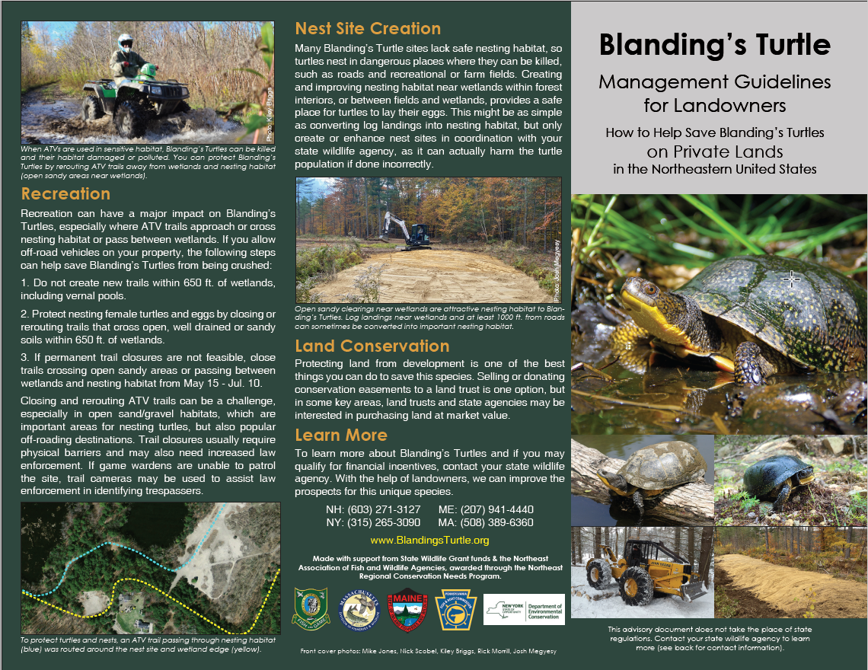
Figure 2. Cover and back panels of a brochure outlining Best Management Practices for Blanding’s Turtles intended for use by interested landowners. One thousand copies were printed and distributed to states, and a PDF will be available at www.BlandingsTurtle.org

