**NORTHEAST REGIONAL CONSERVATION NEEDS GRANT**

**FINAL REPORT**

Grant Program, Number and Title:

2010-03 “*Identification of Tidal Marsh Bird Focal Areas in BCR 30*”

W. Gregory Shriver, 250 Townsend Hall, Department of Entomology and Wildlife Ecology, University of Delaware, Newark, Delaware 19716, USA; gshriver@udel.edu

Whitney A. Wiest, 250 Townsend Hall, Department of Entomology and Wildlife Ecology, University of Delaware, Newark, Delaware 19716, USA; wwiest@udel.edu

Maureen D. Correll, 211 Deering Hall, School of Biology & Ecology, Climate Change Institute, University of Maine, Orono, Maine 04469, USA; maureen.correll@maine.edu

Brian J. Olsen, 5722 Deering Hall, School of Biology & Ecology, Climate Change Institute, University of Maine, Orono, Maine 04469-5722, USA; brian.olsen@maine.edu

Chris S. Elphick, Ecology & Evolutionary Biology, University of Connecticut, 75 North Eagleville Road, U-43, Storrs, Connecticut 06269, USA; chris.elphick@uconn.edu

Thomas P. Hodgman, Maine Department of Inland Fish and Wildlife, 650 State Street, Bangor, Maine 04401-5654, USA; tom.hodgman@maine.gov

David R. Curson, Audubon Maryland-DC, 2901 East Baltimore Street, Baltimore, Maryland 21224, USA; dcurson@audubon.org

**INTRODUCTION**

Tidal marshes are dynamic ecosystems sensitive to climate change primarily through accelerated sea level rise and increased coastal storm severity (Morris et al. 2002, Schuerch et al. 2013). Increases in flooding events and salinity regime changes impact vegetation structure and zonation (Roman et al. 1984, Olff et al. 1997, Howes et al. 2010) and temperature increases alter food-web dynamics (Hoegh-Guldberg and Bruno 2010). Increased sea levels coupled with low sediment supply and vertical accretion rates convert tidal marsh to open water, a process that has been occurring in some marsh systems for decades (e.g., Blackwater National Wildlife Refuge; Kearney et al. 2002, Kearny 2008). Accelerated sea level rise jeopardizes the persistence of tidal marshes worldwide, the ecosystem services marshes provide, and the flora and fauna the habitat supports (Craft et al. 2009, Kirwan et al. 2010). The loss of suitable breeding habitat threatens the population viability of avian tidal marsh specialist birds (Shriver and Gibbs 2004, Gjerdrum et al. 2005, Shriver et al. 2007, Kern and Shriver 2014) and contributes to the sensitivity of these birds to climate change (North American Bird Conservation Initiative, U.S. Committee 2010).

Tidal marsh bird populations are vulnerable to the ongoing and predicted changes to saltmarsh habitat quantity and quality; therefore, reliable abundance and trend estimates are necessary to identifying priority conservation areas and strategies before populations are threatened with rapid declines or extinction. The unique tidal marsh biological community is important on a global scale, is under imminent threat of loss or severe degradation, and its unique characteristics present management challenges necessitating large-scale, collaborative conservation action. The distribution and abundance of 5 tidal marsh birds in northeastern North America (Clapper Rail, *Rallus crepitans*; Willet, *Tringa semipalmata*; Nelson’s Sparrow, *Ammodramus nelsoni*; Saltmarsh Sparrow, *A. caudacutus*; and Seaside Sparrow, *A. maritimus*) is relatively unknown. Saltmarsh Sparrow is listed as globally vulnerable due to the species’ small, heavily fragmented range and continuing decline in suitable habitat (BirdLife International 2012a). In the Northeast USA, each of these species has been identified as a Species of Greatest Conservation Need (SGCN) in the Wildlife Action Plans of multiple states (e.g., New Hampshire Fish and Game Department 2005, Delaware Division of Fish and Wildlife 2006, New Jersey Division of Fish and Wildlife 2008) and all Northeast states have identified tidal marshes as key habitat for SGCN species.

The North American Breeding Bird Survey (BBS) has been successful in estimating population trends of many landbirds and identifying species in need of immediate conservation action to wildlife management agencies (Robbins et al. 1986, 1989, Peterjohn and Sauer 1999, North American Bird Conservation Initiative, U.S. Committee 2009, 2010, 2014). The BBS, however, relies on roadside counts and inadequately samples emergent wetlands (Gibbs and Melvin 1993, Lawler and O’Connor 2004), thereby limiting its application to estimating trends in marsh bird populations. Marsh bird distribution information can be gathered from Breeding Bird Atlas data, but sampling protocols have varied across states, are performed in different years, and may not provide detailed enough information in the necessary timeframe (Shriver et al. 2004). To address this information need, Johnson et al. (2009) developed and proposed a sampling design framework specific to secretive marsh birds with the overarching goal of estimating species distributions, abundances, and population trends. This approach was successfully piloted by the U.S. Fish and Wildlife Service (USFWS) and seven state agencies (Florida, Idaho, Kentucky, Michigan, New York, Ohio, and Wisconsin; Brady and Paulios 2010, Seamans 2011) and was found to be a cost effective and appropriate approach for monitoring marsh birds. Data from this monitoring design can be incorporated into an adaptive management program that fully integrates monitoring with management and directs research to guide emergent conservation questions, such as mitigating the impacts of climate change (Conroy et al. 2010).

Here, we apply the Johnson et al. (2009) approach to monitor tidal marsh birds in the Northeast USA (Maine – Virginia; hereafter Northeast). A coordinated, region-wide effort to collect data using a single sampling design and standardized protocols (Johnson et al. 2009, Conway 2011) is needed to estimate population trends (Shriver et al. 2004) and compare species abundances across Northeast marsh systems with confidence (Conway and Droege 2006). The goal of this project was to provide the information necessary for the states in the New England/Mid-Atlantic Coast Bird Conservation Region (BCR 30) to protect regionally important habitats for tidal marsh birds and provide a consistent platform for tidal marsh bird monitoring in the face of anticipated sea level rise and upland/watershed development. Our study is the first to use the recommended sampling framework for a systematic bird survey in tidal marshes. Our objectives were to: (1) develop and implement the Johnson et al. (2009) sampling framework to inventory tidal marsh birds in the Northeast and provide the foundation for monitoring, (2) estimate the occurrence and abundance of Clapper Rail, Willet, Nelson’s Sparrow, Saltmarsh Sparrow, and Seaside Sparrow, and (3) identify regional population centers and specific areas for conservation of these species.

**METHODS**

**Study Area**

We conducted this research in tidal marsh habitat from Maine to Virginia during the 2011-12 breeding seasons (April-July). Coastal marshes from the Canada-Maine border to Cape Cod, Massachusetts on the Gulf of Maine are classified as Acadian coastal salt marsh (NatureServe ID: CES201.578; Comer et al. 2003, Ferree and Anderson 2013). These polyhaline marshes are interspersed throughout the rocky sections of the Gulf of Maine coast along the ocean shoreline and estuary mouths. Acadian coastal salt marsh is dominated by graminoids *Spartina patens* and *S. alterniflora,* and includes patches of other graminoids (e.g., *Juncus balticus*, *J. gerardii*, and *Puccinellia maritima*)and forbs (e.g., *Limonium carolinianum* and *Plantago maritima var. juncoides*). Acadian coastal salt marshes typically occur as small patches, but may be more extensive where topography allows, although rarely as extensive as tidal marshes elsewhere along the USA Atlantic coast (Comer et al. 2003, Ferree and Anderson 2013). Coastal tidal marshes from Cape Cod, Massachusetts, to the mouth of the Chesapeake Bay, and intermittently along the southern coast of the Gulf of Maine to southern Maine, are classified as northern Atlantic Coastal Plain tidal salt marsh (NatureServe ID: CES203.519; Comer et al. 2003, Ferree and Anderson 2013) . This intertidal system occurs on the bayside of barrier beaches and along the outer mouths of tidal rivers where saline to mesohaline conditions are not strongly impacted by freshwater flow. Northern Atlantic Coastal Plain tidal salt marshes are also dominated by graminoids *S. patens* and *S. alterniflora,* but tend to have more *Distichlis spicata* and *Salicornia* sp. than Acadian coastal salt marsh, as well as more developed shrub upland borders containing *Iva frutescens, Baccharis halimifolia*, *Panicum virgatum*, and *Juniperus virginiana*.

**Sampling Design**

We used a two-stage cluster sampling design (Thompson 2012) with generalized random-tessellation stratified (GRTS) sampling at each stage (Stevens and Olsen 1999, 2003, 2004) to distribute survey points. The sampling design followed the general sample selection protocol recommendations developed by Johnson et al. (2009) to monitor secretive marsh birds at regional and continental scales. The GRTS survey design emphasizes a spatially-balanced sample distribution; a sample is dispersed such that the spatial density pattern of the sample closely mimics the spatial density pattern of the environmental resource (Stevens and Olsen 1999, 2003, 2004). The two-stage cluster design required a geographical division of the study area and separate selection protocols for the two types of sampling units, primary sampling units (PSUs; hexagons) and secondary sampling units (SSUs; survey points). We used a North American continental hexagon grid (40 km2 hexagons) to generate the PSU sampling universe (Seamans 2011). We selected the subset of the continental grid that included all hexagons located in the 10 Northeast U.S. coastal states (Figure 1) that contained Estuarine Intertidal Emergent Wetland (code ‘E2EM’; Cowardin et al. 1979). We used state wetland geospatial data from the National Wetlands Inventory (NWI; Wilen and Bates 1995, National Wetlands Inventory 2010) to determine the extent and location of salt marsh throughout the region. We compiled and processed the Estuarine Intertidal Emergent Wetland geospatial features in ArcGIS ver. 9.3 (ESRI 2009) to develop a single spatial layer of salt marsh in the Northeast. Northeast hexagons that contained salt marsh became the sampling universe for the selection of PSUs (Table 2).

We used the ‘spsurvey’ package (Kincaid and Olsen 2012) in the R statistical program (R Core Team 2014) to select hexagons and survey points. We used three sampling strata to select hexagons: subregion, state lands, and federal lands (US Fish and Wildlife Service [USFWS] and National Park Service [NPS]). Subregion boundaries were based on Conway and Droege (2006) and generally delineated by major geomorphological features (e.g., Long Island, Delmarva Peninsula, Chesapeake Bay; Figure 1, Table 2). We randomly selected 25 hexagons as the core sample and 10 hexagons as oversample for the initial hexagon selection within each subregion (GRTS selection). Next, we randomly selected 25 hexagons that contained tidal marsh on state lands in each subregion. Finally, we selected all hexagons that contained tidal marsh on USFWS and NPS lands because the two agencies conduct wildlife surveys and are likely to continue to do so into the future. We used spatial data from the Protected Areas Database (U.S. Geological Survey, Gap Analysis Program 2011) to determine the hexagons that contained protected tidal marsh. We combined the federal lands hexagons with the GRTS-selected hexagons to create the sampling frame. We excluded hexagons that contained less than 10 ha of marsh; hexagons with less marsh can support fewer sampling points, potentially requiring excessive travel time for a few sampling locations.

We used ‘spsurvey’ to randomly locate 10 survey points and 10 oversample survey points in each hexagon. To improve our ability to make comparisons with previous tidal marsh surveys, we also acquired coordinates of existing tidal marsh bird survey points from historical and ongoing marsh bird surveys (20 projects total; Table 1. We used ArcGIS to combine existing point locations with the randomly generated points, retaining random points 400 m or more from established points. Point spacing followed the Standardized North American Marsh Bird Monitoring Protocol’s recommendation of a minimum distance of 400 m between survey points (Conway 2011). Once the previously established and new, randomly selected points were identified, we ground-truthed all sampling points, prioritizing established points that had historical survey data. We ground-truthed the established points first (if the hexagon possessed them) and then the randomly located survey points followed by the oversample points until we had identified up to 10 survey points in appropriate saltmarsh habitat in each selected hexagon.

**Defining Saltmarsh Patches**

We delineated habitat patches to assess species abundance within discrete, biologically relevant spatial areas and to allow for comparisons in abundance patterns across the landscape. We used the Estuarine Intertidal Emergent Wetland spatial layer developed in the survey sampling design to define saltmarsh habitat patches. We used ArcGIS ver. 9.3 (ESRI 2009) to create a 50 m buffer around the polygon features. Polygons with buffers that intersected were considered the same patch based on home range size and movement estimates for Saltmarsh and Nelson’s sparrows (Shriver et al. 2010). For each defined patch we recorded the state (e.g., Maine, New Hampshire), subregion (e.g., Coastal Maine, Cape Cod – Casco Bay), longitude, latitude, and area.

**Bird Sampling**

We used the North American Marsh Bird Monitoring Protocol (Conway 2011) to estimate the occurrence and abundance of tidal marsh birds within our study region. At all survey points during the 2011-12 breeding seasons, we conducted 5-minute passive point-counts followed immediately by a sequence of 30-second marsh bird playbacks for a suite of species. A single observer surveyed each sampling point two or three times from April 15 to July 31 each year. Visits to survey points were at least 10 days apart. The list of playback species and survey period dates were tailored for each sampling subregion (see [www.tidalmarshbirds.org](http://www.tidalmarshbirds.org)). We recorded birds seen and/or heard using the marsh during 5, consecutive 1-minute time intervals. We recorded the distance of first detection for each individual encountered in three distance bands: 0–50 m, 50–100 m, >100 m. We conducted surveys in the morning from 30 minutes before sunrise to ~1100 hours. We did not survey during high winds, sustained rain, or heavy fog. We used detections of marsh birds from the 0–50 m distance interval and the 0–5 minute passive period for all following analyses to standardize the sampling procedure across the entire region.

**Bird Species Occurrence and Abundance**

We estimated the mean percent occurrence for Clapper Rail, Willet, and Nelson’s, Saltmarsh, and Seaside sparrows in each subregion. We used the ‘unmarked’ package (Fiske and Chandler 2011) in the R statistical program (R Core Team 2014) to estimate marsh bird abundance within each surveyed patch. We used a general multinomial-Poisson mixture model (Royle 2004) using the unmarked fitting function ‘multinomPois’ to estimate abundance for each species. We estimated abundance for each species within each surveyed patch defined above. We used time-of-detection to estimate species detection probability, using the one-minute time intervals within surveys as repeat samples (Farnsworth et al. 2002). We modeled detection as a function of survey visit to control for seasonal differences in detection rates. We estimated the abundance within the species breeding ranges as follows: Clapper Rail (south of 41.3390°N; Rush et al. 2012), Saltmarsh Sparrow (south of 44.0753°N; Greenlaw and Rising 1994), Nelson’s Sparrow (north of 42.8520°N; Shriver et al. 2011), and Seaside Sparrow (south of 42.9185°N; Post and Greenlaw 2009). We estimated Willet abundance for all patches because this species breeds throughout the entire region (Lowther et al. 2001). For each species, we developed subregion specific models in ‘unmarked’ to estimate density for each year and patch. We applied the area sampled to the ‘unmarked’ abundance estimates to convert the estimates to density. When a model could not converge on a species’ patch density estimate, we applied the species’ global mean density estimate for a given year to that patch. We averaged the 2011 and 2012 patch density estimates to calculate mean patch density for each species.

We calculated the mean species density using occupied marsh patches with density estimates ≥0.01 birds per ha for each subregion and across the Northeast, and used one-way ANOVA and Tukey HSD tests (P < 0.05) to test for differences. We multiplied mean species density and occupied patch area to estimate species abundance. We calculated 95% confidence intervals for mean species density and multiplied the lower and upper bounds by the occupied patch area to create 95% confidence intervals for the estimated abundance (Zar 1999). Means are presented as mean ± SE.

**RESULTS**

**Sampling Design**

**Sampling universe.**The primary sampling universe in surveyed subregions (1-8) consisted of 1,110 total hexagons containing 280,722 ha of salt marsh (Table 2). The number of hexagons in each subregion ranged from 88 hexagons in Delaware Bay (59,956 ha of salt marsh), to 212 hexagons in Eastern Chesapeake Bay (78,337 ha of salt marsh). Because we stratified our sampling effort independent of the extent of salt marsh in a subregion, a large sample of total hexagons did not indicate a large quantity of salt marsh. For example, Coastal Maine contained the second highest number of hexagons (*n* = 208), but the smallest area of salt marsh (6,223 ha), and Coastal New Jersey contained two more hexagons than Long Island, but encompassed 40,434 ha (408%) more salt marsh.

**Sampled hexagons.** We sampled 277 (135,042 ha of salt marsh) of the 1,110 total hexagons from Coastal Maine to Eastern Chesapeake Bay. The number of hexagons surveyed in each subregion ranged from 22 in Eastern Chesapeake Bay to 44 in Cape Cod – Casco Bay (Table 2). Marsh owned by state agencies occurred in 127 of the surveyed hexagons; 60 surveyed hexagons contained both state and federally-owned marsh; and an additional 32 surveyed hexagons contained marsh owned by federal agencies only. Of the 92 surveyed hexagons containing federally-owned marsh, 23 hexagons contained NPS-owned marsh, 63 hexagons contained USFWS-owned marsh, and 6 hexagons contained marsh owned by both agencies.

**Sampled survey points.**We sampled 1,780 survey points in the sampled hexagons. Surveyed points were composed of 1,314 new points and 466 historical points from 18 of the 20 projects (Table 1). The number of survey points in each subregion ranged from 119 points in Long Island to 340 points in Cape Cod – Casco Bay (Table 2). We sampled 1,642 points in 2011, 1,714 points in 2012, and 1,575 points in both 2011 and 2012. Survey points included a mix of wetland edge and marsh interior locations, and were accessed by foot, vehicle, and both non-motorized and motorized boats.

**Defining Saltmarsh Patches**

We defined 13,332 saltmarsh habitat patches in the Northeast (Table 4). Total patches per subregion ranged from 166 patches in Delaware Bay to 4,927 patches in Western Chesapeake Bay. Although Delaware Bay had the fewest defined patches, these patches averaged largest (mean = 360 ± 145 ha). Patches north and south of Delaware Bay in Coastal New Jersey and Coastal Delmarva also were large and shared similar average area dimensions: roughly 500 patches in each subregion with a mean area of ~95 ± 27 ha. Cape Cod – Casco Bay also contained ~500 patches, but patches were smaller (38 ± 8 ha). Mean patch area in Long Island and Eastern Chesapeake Bay was 14 ± 1 ha and 23 ± 9 ha, respectively. In Coastal Maine, Southern New England, and Western Chesapeake Bay, saltmarsh patches consisted of many (over 1,000) small patches less than 10 ha in area.

**Bird Species Occurrence and Abundance**

**Clapper Rail.** We detected Clapper Rails from Southern New England south and Clapper Rail percent occurrence was greatest in Coastal Delmarva (49 ± 5%; Table 3). Mean Clapper Rail density was 0.58 ± 0.07 birds per ha in occupied patches across the Northeast (*n* = 91) and did not differ among subregions (*F*5,85= 1.59, *P* = 0.17; Figure 2A and Table 4). Clapper Rail estimated abundance was 106,814 birds (95% CI = 82,385 to 131,242 birds) across all detected patches (Table 4). Regionally, Clapper Rail density was greatest in Coastal Delmarva, ranging from 0.04 – 2.75 birds per ha (mean = 0.85 ± 0.15 birds per ha) and peaked at the south end of Chincoteague Island with a patch area of 165 ha (Figure 8A). Clapper Rail density in Coastal New Jersey ranged from 0.04 – 3.73 birds per ha (mean = 0.58 ± 0.15 birds per ha) and was greatest at the Rainbow Islands in Great Egg Harbor Bay with a patch area of 82 ha (Figure 6A). Clapper Rail density in Long Island ranged from 0.07 – 1.41 birds per ha (mean = 0.46 ± 0.12 birds per ha) and was greatest in a part of Gilgo State Park with a patch area of 30 ha (Figure 5A). Eastern Chesapeake Bay Clapper Rail density ranged from 0.05 – 1.50 birds per ha (mean = 0.46 ± 0.12 birds per ha) and was greatest at Finneys Island with a patch area of 36 ha (Figure 8A). In Delaware Bay, Clapper Rail density ranged from 0.11 – 1.16 birds per ha (mean = 0.42 ± 0.10 birds per ha) and was greatest at part of Heislerville Wildlife Management Area (WMA) with a patch area of 75 ha (Figure 7A).

**Willet**. We detected Willets in all subregions. Willet percent occurrence was 13 ± 1% or greater from Casco Bay south and was greatest in Coastal Delmarva (39 ± 1%; Table 3). Mean Willet density was 0.82 ± 0.06 birds per ha in occupied patches across the Northeast (*n =* 165) and differed among subregions (*F*7,157= 3.11, *P* = 0.004; Figure 2B and Table 4). Mean Willet density was 3.3 times greater in Long Island (*P* = 0.006) and 2.9 times greater in Southern New England (*P* = 0.03) than Cape Cod – Casco Bay. Mean Willet density did not differ between other subregions (*P* > 0.05). Willet estimated abundance was 158,152 birds (95% CI = 133,699 to 182,606 birds) across all detected patches (Table 4). Regionally, Willet density was greatest in Long Island, ranging from 0.09 – 3.66 birds per ha (mean = 1.19 ± 0.16 birds per ha), and peaked at Lanes Island and part of Shinnecock County Park West with a patch area of 46 ha (Figure 5B). Southern New England had the next greatest Willet density, where it ranged from 0.05 – 4.43 birds per ha (mean = 1.03 ± 0.17 birds per ha) and was greatest at Stage Island and Davis Beach with a patch area of 16 ha (Figure 5B). Willet density in Coastal New Jersey ranged from 0.05 – 2.60 birds per ha (mean = 0.79 ± 0.15 birds per ha) and was greatest at Little Beach- E.B. Forsythe National Wildlife Refuge (NWR) with a patch area of 1,598 ha (Figure 6B). Coastal Delmarva Willet density ranged from 0.08 – 2.07 birds per ha (mean = 0.72 ± 0.10 birds per ha) and was greatest at part of Pirate Islands-Assateague Island National Seashore with a patch area of 4 ha (Figure 8B). Coastal Maine Willet density ranged from 0.22 – 1.97 birds per ha (mean = 0.67 ± 0.33 birds per ha) and was greatest at part of Hay Creek with a patch area of 5 ha (Figure 3A). In Delaware Bay, Willet density ranged from 0.33 – 1.10 birds per ha (mean = 0.62 ± 0.12 birds per ha) and was greatest at the marsh extending from Mill Creek to Cohansey River with a patch area of 7,979 ha (Figure 7B). In Cape Cod – Casco Bay, Willet density ranged from 0.05 – 1.10 birds per ha (mean = 0.36 ± 0.06 birds per ha) and was greatest at the marsh complex extending from the Merrimack River mouth along Plum Island-Parker River NWR with a patch area of 1,322 ha (Figure 4A). Eastern Chesapeake Bay Willet density ranged from 0.06 – 0.88 birds per ha (mean = 0.29 ± 0.10 birds per ha) and was greatest at marsh along Tarkill Creek with a patch area of 189 ha (Figure 8B).

**Nelson’s Sparrow.** Nelson’s Sparrow percent occurrence was greatest in Coastal Maine (34 ± 1%; Table 3). Mean Nelson’s Sparrow density was 0.94 ± 0.11 birds per ha in occupied patches across Coastal Maine and Cape Cod – Casco Bay (*n =* 57), and differed between subregions (*F*1,55= 6.22, *P* = 0.02; Table 4). Mean Nelson’s Sparrow density was 2.3 times greater in Coastal Maine than Cape Cod – Casco Bay. Nelson’s Sparrow estimated abundance was 5,376 birds (95% CI = 4,167 to 6,585 birds) across all detected patches (Table 4). Nelson’s Sparrow density was greatest in Coastal Maine, ranging from 0.06 – 3.28 birds per ha (mean = 1.08 ± 0.13 birds per ha) and was greatest at a marsh along the Machias River with a patch area of 34 ha (Figure 3B). Cape Cod – Casco Bay Nelson’s Sparrow density ranged from 0.02 – 1.29 birds per ha (mean = 0.48 ± 0.11 birds per ha) and was greatest at Scarborough Marsh with a patch area of 889 ha (Figure 4B).

**Saltmarsh Sparrow.** We detected Saltmarsh Sparrows in all subregions; however, average percent occurrence varied geographically with no clear pattern from north to south (Table 3). Saltmarsh Sparrow percent occurrence ranged from 2 ± 2% in Coastal Maine to 26 ± 1% in Southern New England. Mean Saltmarsh Sparrow density was 0.46 ± 0.05 birds per ha in occupied patches across the Northeast (*n =* 192) and differed among subregions (*F*7,184= 2.64, *P* = 0.01; Figure 2C and Table 4). Mean Saltmarsh Sparrow density was 2.2 times greater in Southern New England than Long Island (*P* = 0.02), but did not differ between other subregions (*P* > 0.05). Saltmarsh Sparrow estimated abundance was 76,712 birds (95% CI = 61,382 to 92,042 birds) across all detected patches (Table 4). Regionally, Saltmarsh Sparrow density was greatest in Southern New England, ranging from 0.06 – 4.34 birds per ha (mean = 0.73 ± 0.12 birds per ha) and peaked at Monomoy NWR with a patch area of 37 ha (Figure 5C). Coastal New Jersey had the next greatest Saltmarsh Sparrow density where it ranged from 0.07 – 2.06 birds per ha (mean = 0.53 ± 0.12 birds per ha) and was greatest at Cedar Creek Point and Sloop Point with a patch area of 45 ha (Figure 6C). In Cape Cod – Casco Bay, Saltmarsh Sparrow density ranged from 0.06 – 1.95 birds per ha (mean = 0.50 ± 0.10 birds per ha) and was greatest at a marsh in Wellfleet Harbor with a patch area of 416 ha (Figure 4C). Saltmarsh Sparrow density in Long Island ranged from 0.01 – 2.75 birds per ha (mean = 0.33 ± 0.07 birds per ha) and was greatest at two marsh patches, Thatch Island (area = 42 ha) and Elder Island (area = 34 ha; Figure 5C). Coastal Delmarva Saltmarsh Sparrow density ranged from 0.02 – 0.62 birds per ha (mean = 0.27 ± 0.05 birds per ha) and was greatest at the marsh complex extending along Newport and Chincoteague bays, from Spence Cove to Scarboro Creek, with a patch area of 1,711 ha (Figure 8C). In Coastal Maine, Saltmarsh Sparrow density ranged from 0.02 – 0.60 birds per ha (mean = 0.17 ± 0.09 birds per ha) and was greatest at Back Cove Park with a patch area of 2 ha (Figure 3C). In Eastern Chesapeake Bay, Saltmarsh Sparrow density ranged from 0.01 – 0.24 birds per ha (mean = 0.11 ± 0.04 birds per ha) and was greatest at the marsh complex extending from Taylors Island to the Nanticoke River with a patch area of 27,779 ha (Figure 8C). Delaware Bay Saltmarsh Sparrow density ranged from 0.06 – 0.13 birds per ha (mean = 0.09 ± 0.02 birds per ha) and was greatest at the marsh complex extending from Silver Run Wildlife Area to Bowers Beach with a patch area of 16,937 ha (Figure 7C).

**Seaside Sparrow.** Seaside Sparrow percent occurrence was 19 ± 5% or greater from Long Island south and was greatest in Eastern Chesapeake Bay (64 ± 6%; Table 3). Mean Seaside Sparrow density was 0.86 ± 0.09 birds per ha in occupied patches across the Northeast (*n =* 92) and differed among subregions (*F*6,85= 2.71, *P* = 0.02; Figure 2D and Table 4). Mean Seaside Sparrow density did not differ between subregions (*P* > 0.05), but the difference was borderline for Coastal Delmarva and Long Island (*P* = 0.052). Mean Seaside Sparrow density was 2.8 times greater in Coastal Delmarva than Long Island. Seaside Sparrow estimated abundance was 140,952 birds (95% CI = 110,167 to 171,737 birds) across all detected patches (Table 4).

Regionally, Seaside Sparrow density was greatest in Coastal Delmarva, ranging from 0.03 – 4.11 birds per ha (mean = 1.31 ± 0.30 birds per ha) and peaked at a part of Pirate Islands-Assateague Island National Seashore with a patch area of 6 ha (Figure 8D). Delaware Bay had the next greatest Seaside Sparrow density where it ranged from 0.22 – 2.52 birds per ha (mean = 1.29 ± 0.31 birds per ha) and was greatest at the marsh extending from Mill Creek to Cohansey River with a patch area of 7,979 ha (Figure 7D). In Eastern Chesapeake Bay, Seaside Sparrow density ranged from 0.22 – 2.07 birds per ha (mean = 1.19 ± 0.17 birds per ha) and was greatest at the marsh complex extending from Back Creek to Hall Creek with a patch area of 3,051 ha (Figure 8D). Coastal New Jersey Seaside Sparrow density ranged from 0.07 – 3.92 birds per ha (mean = 0.82 ± 0.18 birds per ha) and was greatest at Cedar Creek Point and Sloop Point with a patch area of 45 ha (Figure 6D). Seaside Sparrow density in Long Island ranged from 0.03 – 2.36 birds per ha (mean = 0.47 ± 0.14 birds per ha) and was greatest at Thatch Island with a patch area of 42 ha (Figure 5D). Seaside Sparrow density in Southern New England ranged from 0.13 – 1.99 birds per ha (mean = 0.43 ± 0.17 birds per ha) and was greatest in marshes at the Connecticut River mouth, including the Great Island WMA, with a patch area of 376 ha (Figure 5D). Cape Cod – Casco Bay Seaside Sparrow density ranged from 0.11 – 0.16 birds per ha (mean = 0.13 ± 0.03 birds per ha) and was greatest at a marsh along Weymouth Fore River with a patch area of 4 ha (Figure 4D).

**DISCUSSION**

We detected tidal marsh specialist birds throughout the Northeast at varying densities in the subregions and provide the first comprehensive assessment of the distribution for these taxa in the Northeast USA. Marshes in the core and near the peripheries of the study area hosted species in the highest and lowest density ranges, as depicted in Figures 3-8. The flexibility and probabilistic design of our sampling framework was critical to successful development and implementation of our regional monitoring scheme. By sampling marsh birds in saltmarsh breeding habitat in all ten coastal northeast states in two years, we have created a baseline platform for future monitoring efforts. Our systematic data collection at the regional scale provides contemporary information on patterns of occurrence and abundance of specialist tidal marsh species and allows for the identification of priority areas for their conservation.

Clapper Rail densities were greatest in extensive back-barrier lagoon marsh systems in Coastal Delmarva and Coastal New Jersey, and in smaller back-barrier systems on Long Island. Clapper Rails occurred in relatively high densities across Virginia marshes on the Delmarva Peninsula, from Chincoteague Bay to Fisherman Island. In Coastal New Jersey, marshes with the greatest Clapper Rail densities were clustered around Great Egg Harbor Bay. On the U.S. East Coast, Clapper Rails prefer low tidal salt marsh that is flooded at least once daily and dominated by *Spartina* sp. of moderate height (Meanley 1985), habitat characteristics indicative of back-barrier lagoon marshes. Mangold (1974) found Clapper Rails in New Jersey tended to use natural and ditched marsh habitats with short-form *S. alterniflora*, followed by areas of tall-form *S. alterniflora*; few Clapper Rails were detected in *S. patens*. Clapper Rails nest in emergent wetlands or scrub/shrub mangroves typically within 15 m of a tidally influenced waterbody (e.g., ditches, creeks, streams, rivers, embayments; Lewis and Garrison 1983), although many East Coast nests are found within 5 m of water (Kozicky and Schmidt 1949, Stewart 1951). Clapper Rail subspecies *crepitans*, formerly *R.* longirostris *crepitans* (del Hoyo et al. 2014), breeds from southern New England to southern North Carolina (Rush et al. 2012) and is more common in southern states as the extent of *S. alterniflora*-dominated low marsh increases. Our higher detection levels and greater density estimates on Coastal Delmarva, as well as the occurrence of high density patches at the southern end of Eastern Chesapeake Bay on the Eastern Shore of Virginia, are consistent with the expected distribution and density patterns of the subspecies.

Willet occurrence was widespread in the Northeast; the Eastern Willet subspecies *semipalmatus* has a large latitudinal breeding range, extending along the North American Atlantic and Gulf coasts and in the West Indies (Lowther et al. 2001). Willet percent occurrence was greatest in Coastal Delmarva, but overall density was greatest in Long Island and Southern New England. In Long Island, patches with the greatest densities were located in close proximity to inlets, particularly Shinnecock and Fire Island inlets; similarly, Coastal New Jersey Willet densities were greatest around Great Egg Harbor and Little Egg inlets. Across Southern New England, higher density patches were well interspersed with low and zero density patches, but there was a small group of higher density patches clustered around Nantucket Sound, Massachusetts. Mean Willet density in Coastal New Jersey, Delaware Bay, and Coastal Delmarva was comparable. In Coastal Delmarva, Willet densities were greatest around the Maryland-Virginia border; however, local conservation practitioners do not consider the species a tidal marsh specialist since Willets in southern states, including Virginia, often nest in short vegetation behind dunes or on bare ground (Tomkins 1965, Douglas 1996). Willets nesting in non-saltmarsh habitats have also been documented in more northern states (sand dune areas with *Ammophila breviligulata*, Burger and Shisler 1978; sphagnum bog, Wells and Vickery 1990) and in Nova Scotia (open fields and pastures near marshes, Tufts 1986), but nesting habitat in the Northeast remains predominantly salt marsheswith *S. alterniflora* and *S. patens* (Lowther et al. 2001).

Results for Nelson’s Sparrow were consistent with the known U.S. extent of the breeding range of the Acadian race *subvirgatus*, which breeds in salt marshes from Quebec to the northeastern shore of Massachusetts (Greenlaw and Woolfenden 2007). High density patches were scattered throughout Coastal Maine and primarily situated in an estuarine embayment geomorphological setting, both as stream channel wetlands and saline fringe marshes (Cahoon et al. 2009). At the southern end of the range the subspecies occurs sympatrically with Saltmarsh Sparrow (Montagna 1942, Greenlaw 1993, Hodgman et al. 2002); the overlap zone extends from the Weskeag River in South Thomaston, Maine to Parker River NWR in Newburyport, Massachusetts (Hodgman et al. 2002). In general, we encountered both species in the same patches in the overlap zone. Nelson’s Sparrow had higher densities than Saltmarsh Sparrow in most patches from Saco River, Maine to the northern boundary of the overlap zone.

Hybridization between Nelson’s and Saltmarsh sparrows has been documented in the overlap zone (Rising and Avise 1993, Hodgman et al. 2002, Shriver et al. 2005, Walsh et al. 2011) and hybrids can potentially occur in all marshes where the two species co-exist (Shriver et al. 2005, Walsh et al. 2011). In the putative hybrid zone, “pure” individuals are difficult to distinguish from introgressed individuals by morphology alone; at the south end of the zone, individuals confirmed to be hybrids using genetic testing were identified as Saltmarsh Sparrows in the field based on morphological characteristics (Shriver et al. 2005, Walsh et al. 2011). More research across the hybrid zone is needed to determine if there is a bias toward either sparrow phenotype; moreover, the effect of introgression on vocalization remains unstudied. Hybridization has clear implications for detecting species accurately from visual markers and/or vocal cues during point counts. Technicians surveying in the hybrid zone may falsely record an introgressed sharp-tailed sparrow as a “pure” Saltmarsh Sparrow leading to underestimates of hybrids coupled with overestimates of Saltmarsh Sparrows, and vice versa for Nelson’s Sparrow. Additional hybrid research will help improve Nelson’s and Saltmarsh sparrow population estimates and distribution mapping, as well as assist conservation practitioners with weighing the threat of hybridization to species conservation and evaluating possible strategies to protect genetically “pure” populations.

Saltmarsh Sparrow density in individual marsh patches was greatest in New England and Long Island where small groups of patches with higher density estimates were clustered around Nantucket Sound, Massachusetts; Narragansett Bay, Rhode Island; and South Oyster Bay, New York. Our results show that south of the Nelson’s-Saltmarsh overlap zone, Saltmarsh Sparrow was the dominant sparrow inhabiting coastal marshes south to the Barnegat Bay in New Jersey. In Barnegat Bay salt marshes, Seaside Sparrows occur in increasingly higher densities than Saltmarsh Sparrows. Coastal southern New Jersey is also the transition zone for the two forms of Saltmarsh Sparrow; from this area, the northern Saltmarsh Sparrow (*A. c. caudacutus*) breeds north to Maine and the southern Saltmarsh Sparrow (*A. c. diversus*) breeds south to Virginia (Greenlaw and Rising 1994). When compared to density estimates from southern Maine to New Jersey, Saltmarsh Sparrows occurred at low densities in Coastal Maine, Delaware Bay, Coastal Delmarva, and Eastern Chesapeake Bay. The greatest Saltmarsh Sparrow densities in the southern portion of the breeding range were in Chincoteague Bay. We detected Saltmarsh Sparrows in limited numbers around the southern boundary of the species’ breeding range, near the Accomack and Northampton county border on the Eastern Shore of Virginia (Watts and Smith 2010, Wiest personal observation). Overall, the spatial distribution of our Saltmarsh Sparrow detections on the Delmarva Peninsula was similar to the distribution of detections from another recent marsh bird survey (Watts and Smith 2010).

Seaside Sparrow density was greatest in the Mid-Atlantic, consistent with the core of the breeding range for the subspecies *maritima* (Post and Greenlaw 2009). Average Seaside Sparrow percent occurrence was greatest in the bay subregions (Delaware and Eastern Chesapeake bays), but mean subregion density was similar across Delaware Bay, Coastal Delmarva, and Eastern Chesapeake Bay. Marshes with the greatest densities were spatially distributed throughout the three southern subregions and in Coastal New Jersey. Seaside Sparrows occurred on Long Island, but overall patch density was low; the greatest density estimates occurred on the south shore in back-barrier lagoon marsh systems behind Fire and Jones Beach islands. In New York, the species is considered a rare and local breeder in state maritime areas (Arbib 1988, Greenlaw 2008), but presence in subcoastal marshes has been documented (on Hudson River; Bull 1974). Seaside Sparrow breeding populations in New England are localized and disjunct (Post and Greenlaw 2009) and our results aligned with this distribution; individuals were present in low densities in few marsh patches from Massachusetts to Connecticut. The species is rarely detected in Maine and New Hampshire (Post and Greenlaw 2009); we detected one individual in Maine at Scarborough Marsh in 2011, greater than 100 m from the observer.

We mapped bird densities within the single, broad habitat estuarine emergent marsh and did not distinguish among basic saltmarsh zones (e.g., low marsh, high marsh, salt pans, and terrestrial border; Bertness 1999). Habitat use in marsh vegetation zones and in adjacent habitats (e.g., tidal flats, beaches) differs by species (Hanson and Shriver 2006, Nocera et al. 2007, Shriver et al. 2010), and marsh birds are typically concentrated in particular areas, leading to high spatial variation in abundance within a marsh (Conway and Droege 2006). Distribution maps typically illustrate species’ ranges regardless of the array of habitats used (Kantrud 1982), and our density maps illustrate species density across all salt marsh habitat regardless of species dependence and preference for marsh vegetation zone. Therefore, maps should not be construed as the overall species distribution in the study area, a caution common to interpreting larger scale species distribution and abundance maps (Kantrud 1982). Along similar lines, occurrence maps for some species do not necessarily correspond well with species nesting occurrence maps, as is the case for Saltmarsh Sparrow (Meiman et al. 2012), warranting additional caution for this species. Still, our mapping results provide a reasonable means to begin synthesizing tidal marsh specialist bird species occurrence and abundance across a broad geographic region.

Knowing basic species location and population level information is critical to identifying regional and continental scale patterns in species distribution and abundance. Only once these patterns are known can we begin evaluating how distribution and abundance changes through time and space and identify what environmental factors influence these changes, to effectively prioritize conservation actions at these larger scales. Taking a proactive, collaborative, large-scale approach to tidal marsh bird conservation will be necessary to combat the threats of climate change to these species. Habitat patches that we identified as supporting high densities of tidal marsh specialist birds are naturally home to other coastal bird species of conservation concern that are susceptible to the same major threats. For example, Lanes Island in Shinnecock Bay, NY had a high Willet density estimate and supports colonies of state-listed Common Tern (*Sterna hirundo*) and state-listed and federally endangered Roseate Tern (*S. dougallii*; U.S. Fish and Wildlife Service 1997). East Coast U.S. salt marshes are also critically important for American Black Duck (*Anas rubripes*; the species winters in salt marshes) and the globally near threatened Black Rail (*Laterallus jamaicensis*; BirdLife International 2012b); both species are of high conservation concern across their entire range and breed locally at low abundances in BCR 30. Our sampling yielded too few detections to perform analyses for these species and additional monitoring is needed to assess their breeding status in Northeast salt marshes. Evaluating priority marsh bird conservation areas in the context of priority areas for other vulnerable coastal bird species will further help direct the allocation of limited conservation funds, facilitate habitat management strategies and decisions, and focus future monitoring efforts to target information gaps. With a Northeast regional marsh bird monitoring platform now in place, we can begin to shed light on how changes to marsh habitat brought about by climate change and human activity will affect the persistence of tidal marsh bird populations and target our conservation actions to give these species their best chance for survival.

**ACKNOWLEDGEMENTS**

This research was funded by the U.S. Fish and Wildlife Service, Northeast Regional Conservation Needs Grant Program and Region 5 - Division of Wildlife and Sport Fish Restoration under State Wildlife Grant # U2-5-R-1. We would especially like to thank Northeast state, federal, and NGO biologists and their organizations for help with field logistics, additional support, and allowing us to work on their properties. We also thank the numerous private landowners who granted us permission to work on their properties multiple years and supported our research. We thank the 2011 and 2012 Saltmarsh Habitat and Avian Research Program (SHARP) survey field crews for help with data collection, as well as the C. Conway lab for playback sequences, M. Seamans and A. Olsen for assistance with the sampling design and ‘spsurvey’ package, and K. Serno for creating the manuscript’s density maps. The research findings and conclusions in this article are those solely of the authors. No funders had any input into the content of the manuscript nor required their approval of the manuscript before submission or publication.

**LITERATURE CITED**

Arbib, R. 1988. Seaside sparrow. Ammodramus maritimus. Pages 454–455 *in* R. F. Andrle and J. R. Carroll, editors. The Atlas of Breeding Birds in New York State. Cornell University Press, Ithaca, NY.

Bertness, M. D. 1999. The Ecology of Atlantic Shorelines. Sinauer Associates, Sunderland, MA.

BirdLife International. 2012a. Ammodramus caudacutus. www.iucnredlist.org.

BirdLife International. 2012b. Laterallus jamaicensis. www.iucnredlist.org.

Brady, R., and A. Paulios. 2010, January. Implementation of a National Marshbird Monitoring Program: Using Wisconsin as a Test of Program Study Design. Wisconsin Bird Conservation Initiative.

Bull, J. 1974. Birds of New York State. Doubleday, Garden City, NY.

Burger, J., and J. Shisler. 1978. Nest-site selection of willets in a New Jersey salt marsh. The Wilson Bulletin 90:599–607.

Cahoon, D. R., D. J. Reed, A. S. Kolker, M. M. Brinson, J. C. Stevenson, S. Riggs, R. Christian, E. Reyes, C. Voss, and D. Kunz. 2009. Coastal Wetland Sustainability. Pages 57–72 Coastal Sensitivity to Sea-Level Rise: A Focus on the Mid-Atlantic Region. U.S. Climate Change Science Program, Washington D.C., USA.

Comer, P., D. Faber-Langendoen, R. Evans, S. Gawler, C. Josse, G. Kittel, S. Menard, M. Pyne, M. Reid, K. Schulz, K. Snow, and J. Teague. 2003. Ecological systems of the United States: A working classification of U.S. terrestrial systems. NatureServe, Arlington, VA.

Conroy, M. J., R. J. Cooper, S. A. Rush, K. W. Stodola, B. L. Nuse, and M. S. Woodrey. 2010. Effective use of data from marshbird monitoring programs for conservation decision-making. Waterbirds 33:397–404.

Conway, C. J. 2011. Standardized North American Marsh Bird Monitoring Protocol. Waterbirds 34:319–346.

Conway, C. J., and S. Droege. 2006. A unified strategy for monitoring changes in abundance of birds associated with North American tidal marshes. Pages 282–297 Terrestrial Vertebrates of Tidal Marshes: Evolution, Ecology, and Conservation. The Cooper Ornithological Society, Camarillo, CA.

Cowardin, L. M., V. Carter, F. C. Golet, and E. T. LaRoe. 1979. Classification of wetlands and deepwater habitats of the United States. Page 131. U.S. Department of the Interior, Fish and Wildlife Service, Washington, D.C.

Craft, C., J. Clough, J. Ehman, S. Joye, R. Park, S. Pennings, H. Guo, and M. Machmuller. 2009. Forecasting the effects of accelerated sea-level rise on tidal marsh ecosystem services. Frontiers in Ecology and the Environment 7:73–78.

Delaware Division of Fish and Wildlife. 2006. Delaware Wildlife Action Plan 2007 - 2017. Delaware Department of Natural Resources and Environmental Control, Dover, DE.

Douglas, III, H. D. 1996. Communication, evolution and ecology in the Willet (Catoptrophorus semipalmatus): its implications for shorebirds (Suborder Charadrii). M.S. Thesis, Wake Forest University, Winston-Salem, NC.

ESRI. 2009. ArcGIS 9.3. Redlands, CA: Environmental Systems Research Institute.

Farnsworth, G. L., K. H. Pollock, J. D. Nichols, T. R. Simons, J. E. Hines, and J. R. Sauer. 2002. A removal model for estimating detection probabilities from point-count surveys. The Auk 119:414.

Ferree, C., and M. G. Anderson. 2013. A Map of Terrestrial Habitats of the Northeastern United States: Methods and Approach. The Nature Conservancy, Eastern Conservation Science, Eastern Regional Office, Boston, MA.

Fiske, I., and R. Chandler. 2011. unmarked: An R Package for Fitting Hierarchical Models of Wildlife Occurrence and Abundance. Journal of Statistical Software 43:1–23.

Gibbs, J. P., and S. M. Melvin. 1993. Call-response surveys for monitoring breeding waterbirds. Journal of Wildlife Management 57:27–34.

Gjerdrum, C., C. S. Elphick, and M. Rubega. 2005. Nest site selection and nesting success in saltmarsh breeding sparrows: the importance of nest habitat, timing, and study site differences. The Condor 107:849–862.

Greenlaw, J. S. 1993. Behavioral and morphological diversification in sharp-tailed sparrows (Ammodramus caudacutus) of the Atlantic coast. The Auk 110:286–303.

Greenlaw, J. S. 2008. Seaside sparrow. Ammodramus maritimus. Pages 562–563 *in* K. J. McGowan and K. Corwin, editors. The Second Atlas of Breeding Birds in New York State. Cornell University Press, Ithaca, NY.

Greenlaw, J. S., and J. D. Rising. 1994. Saltmarsh Sparrow (Ammodramus caudacutus), The Birds of North America Online (A. Poole, Ed.). Ithaca: Cornell Lab of Ornithology; Retrieved from the Birds of North America Online: http://bna.birds.cornell.edu/bna/species/112.

Greenlaw, J. S., and G. E. Woolfenden. 2007. Wintering distributions and migration of saltmarsh and nelson’s sharp-tailed sparrows. The Wilson Journal of Ornithology 119:361–377.

Hanson, A. R., and W. G. Shriver. 2006. Breeding birds of northeast saltmarshes: habitat use and conservation. Pages 141–154 Terrestrial Vertebrates of Tidal Marshes: Evolution, Ecology, and Conservation. The Cooper Ornithological Society, Camarillo, CA.

Hodgman, T. P., W. G. Shriver, and P. D. Vickery. 2002. Redefining range overlap between the sharp-tailed sparrows of coastal New England. The Wilson Bulletin 114:38–43.

Hoegh-Guldberg, O., and J. F. Bruno. 2010. The Impact of Climate Change on the World’s Marine Ecosystems. Science 328:1523–1528.

Howes, N. C., D. M. FitzGerald, Z. J. Hughes, I. Y. Georgiou, M. A. Kulp, M. D. Miner, J. M. Smith, and J. A. Barras. 2010. Hurricane-induced failure of low salinity wetlands. Proceedings of the National Academy of Sciences 107:14014–14019.

Del Hoyo, J., N. J. Collar, D. A. Christie, A. Elliott, and L. D. C. Fishpool. 2014. HBW and BirdLife International Illustrated Checklist of the Birds of the World. Lynx Edicions and BirdLife International, Barcelona, Spain and Cambridge, UK.

Johnson, D. H., J. P. Gibbs, M. Herzog, S. Lor, N. D. Niemuth, C. A. Ribic, M. Seamans, T. L. Shaffer, W. G. Shriver, S. V. Stehman, and W. L. Thompson. 2009. A Sampling Design Framework for Monitoring Secretive Marshbirds. Waterbirds 32:203–215.

Kantrud, H. A. 1982. Maps of distribution and abundance of selected species of birds on uncultivated native upland grasslands and shrubsteppe in the Northern Great Plains. Page 31. U.S. Department of the Interior, Fish and Wildlife Service, FWS/OBS-82/31.

Kearney, M. S., A. S. Rogers, J. R. G. Townshend, E. Rizzo, D. Stutzer, J. C. Stevenson, and K. Sundborg. 2002. Landsat imagery shows decline of coastal marshes in Chesapeake and Delaware Bays. Eos, Transactions American Geophysical Union 83:173–178.

Kearny, M. S. 2008. The Potential for Significant Impacts on Chesapeake Bay from Global Warming. Pages 85–100 *in* M. C. MacCracken, F. Moore, and J. C. Topping, Jr., editors. Sudden and Disruptive Climate Change: Exploring the Real Risks and How We Can Avoid Them. Earthscan, New York, NY.

Kincaid, T. M., and A. R. Olsen. 2012. spsurvey: Spatial Survey Design and Analysis. R package version 2.3. URL: http//www.epa.gov/nheerl/arm/.

Kirwan, M. L., G. R. Guntenspergen, A. D’Alpaos, J. T. Morris, S. M. Mudd, and S. Temmerman. 2010. Limits on the adaptability of coastal marshes to rising sea level. Geophysical Research Letters 37:1–5.

Kozicky, E. L., and F. V. Schmidt. 1949. Nesting habits of the clapper rail in New Jersey. Auk 66:355–364.

Lawler, J. J., and R. J. O’Connor. 2004. How well do consistently monitored breeding bird survey routes represent the environments of the conterminous United States? The Condor 106:801–814.

Lewis, J. C., and R. L. Garrison. 1983. Habitat suitability index models: clapper rail. Page 15. U.S. Department of the Interior, Fish and Wildlife Service. FWS/OBS-82/10.51.

Lowther, P. E., H. D. Douglas, III, and C. L. Gratto-Trevor. 2001. Willet (Tringa semipalmata), The Birds of North America Online (A. Poole, Ed.). Ithaca: Cornell Lab of Ornithology; Retrieved from the Birds of North America Online: http://bna.birds.cornell.edu/bna/species/579.

Mangold, R. E. 1974. Research on shore and upland migratory birds in New Jersey: clapper rail studies, 1974 final report. Page 17. U.S. Fish and Wildlife Service Accelerated Research Program, New Jersey Department of Environmental Protection, Trenton, NJ.

Meanley, B. 1985. The marsh hen-A natural history of the clapper rail of the Atlantic coast salt marsh. Tidewater Publishers, Centerville, MD.

Meiman, S., D. Civco, K. Holsinger, and C. S. Elphick. 2012. Comparing habitat models using ground-based and remote sensing data: Saltmarsh sparrow presence versus nesting. Wetlands 32:725–736.

Montagna, W. 1942. The sharp-tailed sparrows of the Atlantic coast. The Wilson Bulletin 54:107–121.

Morris, J. T., P. V. Sundareshwar, C. T. Nietch, B. Kjerfve, and D. R. Cahoon. 2002. Responses of coastal wetlands to rising sea level. Ecology 83:2869–2877.

National Wetlands Inventory. 2010. Download Seamless Wetlands Data by State. U.S. Fish and Wildlife Service, Ecological Services.

New Hampshire Fish and Game Department. 2005. New Hampshire Wildlife Action Plan. New Hampshire Fish and Game Department, Concord, NH.

New Jersey Division of Fish and Wildlife. 2008. New Jersey Wildlife Action Plan. New Jersey Department of Environmental Protection, Trenton, NJ.

Nocera, J. J., T. M. Fitzgerald, A. R. Hanson, and G. Randy Milton. 2007. Differential habitat use by Acadian Nelson’s sharp-tailed sparrows: implications for regional conservation. Journal of Field Ornithology 78:50–55.

North American Bird Conservation Initiative, U.S. Committee. 2009. The state of the birds, United States of America, 2009. Page 36. U.S. Department of the Interior, Washington, D.C.

North American Bird Conservation Initiative, U.S. Committee. 2010. The state of the birds 2010 report on climate change, United States of America. U.S. Department of the Interior, Washington, D.C.

North American Bird Conservation Initiative, U.S. Committee. 2014. The state of the birds 2014 report. Page 16. U.S. Department of the Interior, Washington, D.C.

Olff, H., J. D. Leeuw, J. P. Bakker, R. J. Platerink, and H. J. van Wijnen. 1997. Vegetation succession and herbivory in a salt marsh: Changes induced by sea level rise and silt deposition along an elevational gradient. The Journal of Ecology 85:799.

Peterjohn, B. G., and J. R. Sauer. 1999. Population status of North American grassland birds from the North American Breeding Bird Survey. Pages 27–44 Ecology and conservation of grassland birds in the Western Hemisphere. Allen Press, Inc., Lawrence, KS.

Post, W., and J. S. Greenlaw. 2009. Seaside Sparrow (Ammodramus maritimus), The Birds of North America Online (A. Poole, Ed.). Ithaca: Cornell Lab of Ornithology; Retrieved from the Birds of North America Online: http://bna.birds.cornell.edu/bna/species/127.

R Core Team. 2014. R: A Language and Environment for Statistical Computing. R Foundation for Statistical Computing, Vienna, Austria, http://www.R-project.org.

Rising, J. D., and J. C. Avise. 1993. Application of genealogical-concordance principles to the taxonomy and evolutionary history of the sharp-tailed sparrow (Ammodramus caudacutus). The Auk 110:844–856.

Robbins, C. S., D. Bystrak, and P. H. Geissler. 1986. The breeding bird survey: Its first fifteen years, 1965-1979. U.S. Dept. of the Interior, Fish and Wildlife Service Resource Publication 157, Washington, D.C.

Robbins, C. S., J. R. Sauer, R. S. Greenberg, and S. Droege. 1989. Population declines in North American birds that migrate to the neotropics. Proceedings of the National Academy of Sciences 86:7658–7662.

Roman, C. T., W. A. Niering, and R. S. Warren. 1984. Salt marsh vegetation change in response to tidal restriction. Environmental Management 8:141–149.

Royle, J. A. 2004. Generalized estimators of avian abundance from count survey data. Animal Biodiversity and Conservation 27:375–386.

Rush, S. A., K. F. Gaines, W. R. Eddleman, and C. J. Conway. 2012. Clapper Rail (Rallus longirostris), The Birds of North America Online (A. Poole, Ed.). Ithaca: Cornell Lab of Ornithology; Retrieved from the Birds of North America Online: http://bna.birds.cornell.edu/bna/species/340.

Schuerch, M., A. Vafeidis, T. Slawig, and S. Temmerman. 2013. Modeling the influence of changing storm patterns on the ability of a salt marsh to keep pace with sea level rise. Journal of Geophysical Research: Earth Surface 118:84–96.

Seamans, M. 2011. The National Marsh Bird Monitoring Pilot Study; Methods and Preliminary Results (DRAFT). U.S. Fish and Wildlife Service, Division of Migratory Bird Management, Population and Habitat Assessment Branch.

Shriver, W. G., and J. P. Gibbs. 2004. Projected effects of sea-level rise on the population viability of Seaside Sparrows (Ammodramus maritimus). Pages 397–409 *in* H. R. Akçakaya, M. A. Burgman, O. Kindvall, C. C. Wood, P. Sjögren-Gulve, J. S. Hatfield, and M. A. McCarthy, editors. Species Conservation and Management: Case Studies. Oxford University Press, New York, NY.

Shriver, W. G., J. P. Gibbs, P. D. Vickery, H. L. Gibbs, T. P. Hodgman, P. T. Jones, and C. N. Jacques. 2005. Concordance between morphological and molecular markers in assessing hybridization between sharp-tailed sparrows in new england. The Auk 122:94–107.

Shriver, W. G., T. P. Hodgman, J. P. Gibbs, and P. D. Vickery. 2004. Landscape context influences salt marsh bird diversity and area requirements in New England. Biological Conservation 119:545–553.

Shriver, W. G., T. P. Hodgman, J. P. Gibbs, and P. D. Vickery. 2010. Home range sizes and habitat use of Nelson’s and saltmarsh sparrows. The Wilson Journal of Ornithology 122:340–345.

Shriver, W. G., T. P. Hodgman, and A. R. Hanson. 2011. Nelson’s Sparrow (Ammodramus nelsoni), The Birds of North America Online (A. Poole, Ed.). Ithaca: Cornell Lab of Ornithology; Retrieved from the Birds of North America Online: http://bna.birds.cornell.edu/bna/species/719.

Shriver, W. G., P. D. Vickery, T. P. Hodgman, and J. P. Gibbs. 2007. Flood tides affect breeding ecology of two sympatric sharp-tailed sparrows. The Auk 124:552–560.

Stevens, D. L., and A. R. Olsen. 1999. Spatially restricted surveys over time for aquatic resources. Journal of Agricultural, Biological, and Environmental Statistics 4:415–428.

Stevens, D. L., and A. R. Olsen. 2003. Variance estimation for spatially balanced samples of environmental resources. Environmetrics 14:593–610.

Stevens, D. L., and A. R. Olsen. 2004. Spatially balanced sampling of natural resources. Journal of the American Statistical Association 99:262–278.

Stewart, R. E. 1951. Clapper rail populations of the Middle Atlantic States. Transactions of the North American Wildlife Conference 16:421–430.

Thompson, S. K. 2012. Sampling. 3rd edition. John Wiley and Sons, Inc., New York, NY.

Tomkins, I. R. 1965. The Willets of Georgia and South Carolina. The Wilson Bulletin 77:151–167.

Tufts, R. 1986. Birds of Nova Scotia. Nova Scotia Museum, Halifax.

U.S. Fish and Wildlife Service. 1997. Significant Habitats and Habitat Complexes of the New York Bight Watershed. U.S. Fish and Wildlife Service, Charlestown, RI.

U.S. Geological Survey, Gap Analysis Program. 2011. Protected Areas Database of the United States (PADUS).

Walsh, J., A. I. Kovach, O. P. Lane, K. M. O’Brien, and K. J. Babbitt. 2011. Genetic barcode RFLP analysis of the Nelson’s and saltmarsh sparrow hybrid zone. The Wilson Journal of Ornithology:316–322.

Watts, B., and F. Smith. 2010. Southern range limit for breeding in the saltmarsh.

Wells, J. V., and P. D. Vickery. 1990. Willet nesting in sphagnum bog in eastern Maine. Journal of Field Ornithology 61:73–75.

Wilen, B. O., and M. K. Bates. 1995. The US Fish and Wildlife Service’s National Wetlands Inventory project. Vegetatio 118:153–169.

Zar, J. H. 1999. Biostatistical Analysis. Prentice Hall, Upper Saddle River, NJ.

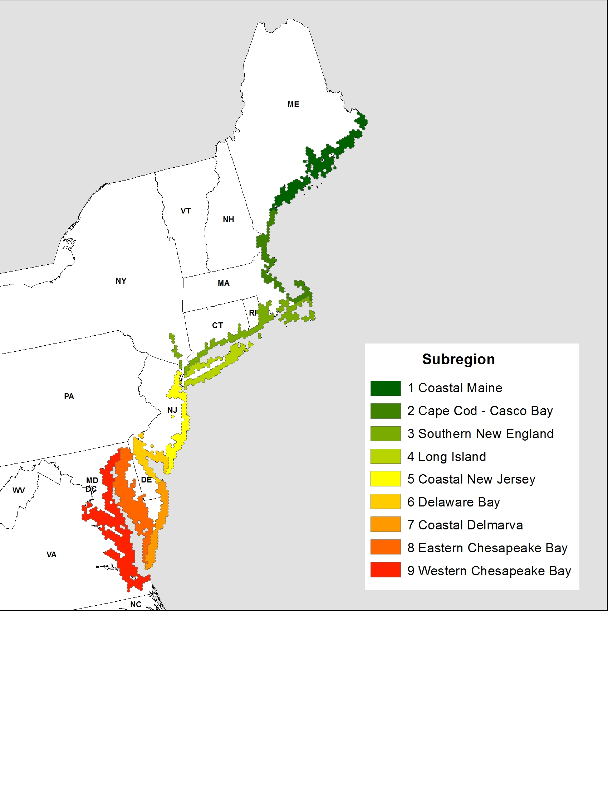

Figure 1. The sampling universe in the Northeast USA delineated into subregions; subregions are composed of 40 km2 hexagons containing estuarine intertidal emergent marsh (also see Table 2). State acronyms: CT – Connecticut, DE – Delaware, DC – District of Columbia, ME – Maine, MD – Maryland, MA – Massachusetts, NH – New Hampshire, NJ – New Jersey, NY – New York, NC – North Carolina, PA – Pennsylvania, RI – Rhode Island, VT – Vermont, VA – Virginia, and WV – West Virginia.



C

D

A

B



Figure 2. Average density (± SE) for tidal marsh specialist birds in the Northeast USA, 2011-12, by subregion (north to south) and region-wide. Means were calculated using surveyed marsh patches with species density estimates ≥0.01 birds per ha (also see Table 4 for sample sizes).

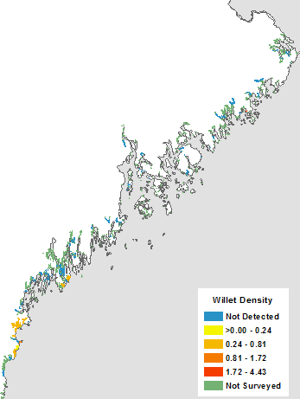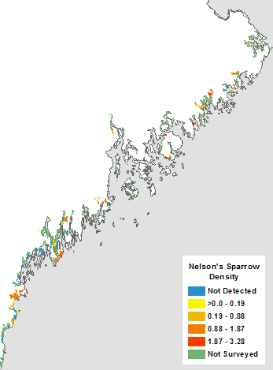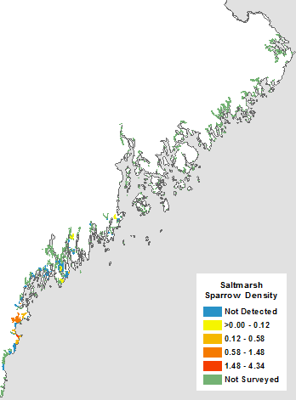

B

C

A

Figure 3. The average species densities (birds per ha) during 2011-2012 for tidal marsh specialist birds in marsh patches in Subregion 1: Coastal Maine.

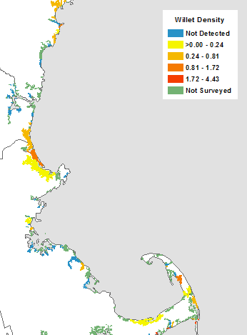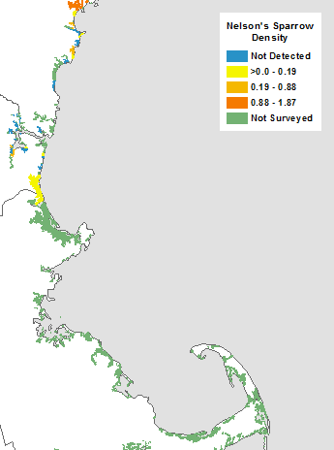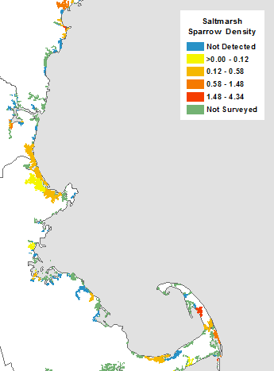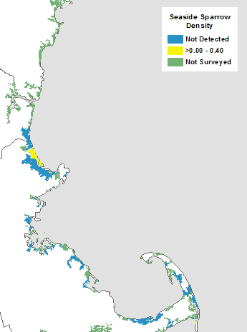

D

A

B

C

Figure 4. The average species densities (birds per ha) during 2011-2012 for tidal marsh specialist birds in marsh patches in Subregion 2: Cape Cod – Casco Bay.

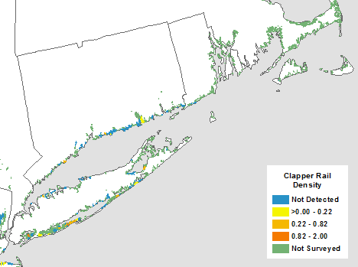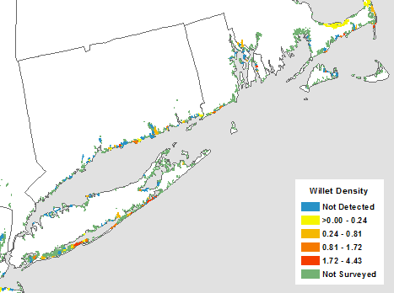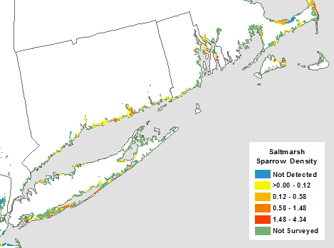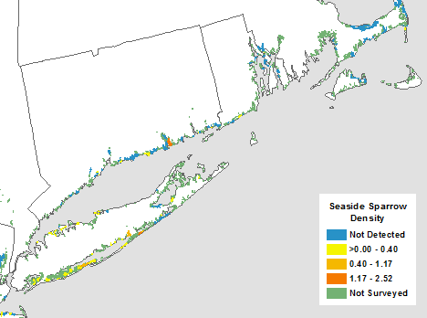

C

D

B

A

Figure 5. The average species densities (birds per ha) during 2011-2012 for tidal marsh specialist birds in marsh patches in Subregions 3 and 4: Southern New England and Long Island.

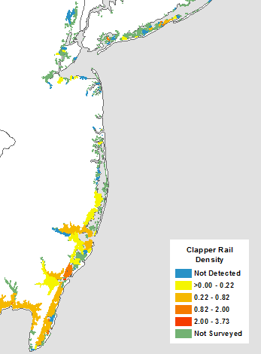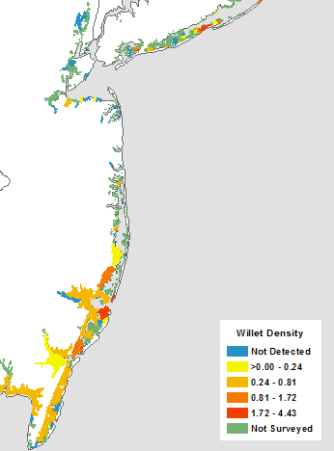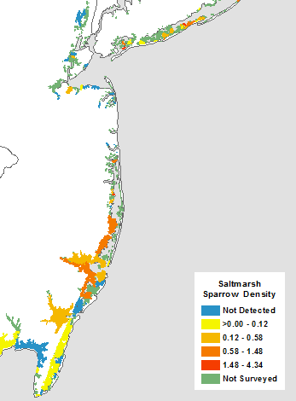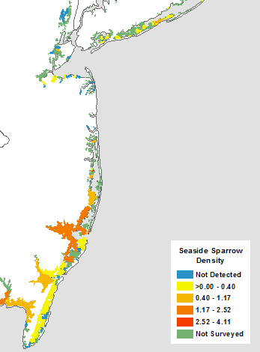

A

B

C

D

Figure 6. The average species densities (birds per ha) during 2011-2012 for tidal marsh specialist birds in marsh patches in Subregion 5: Coastal New Jersey.

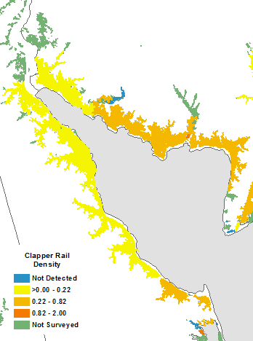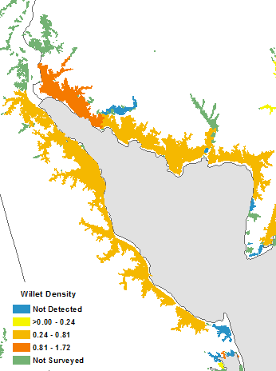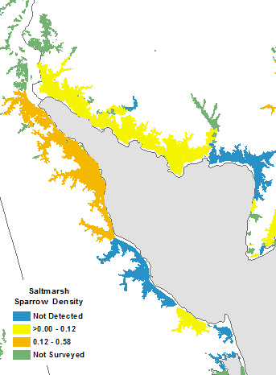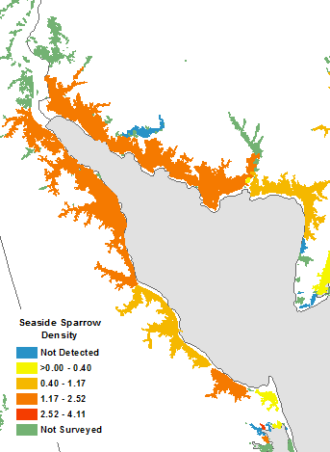

A

B

C

D

Figure 7. The average species densities (birds per ha) during 2011-2012 for tidal marsh specialist birds in marsh patches in Subregion 6: Delaware Bay.

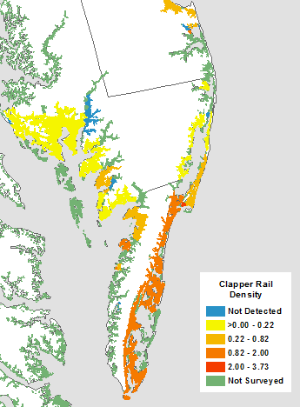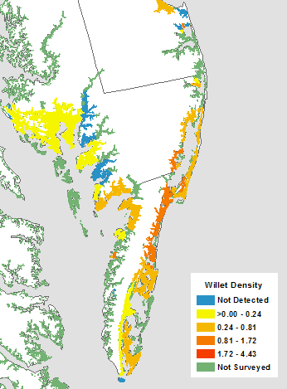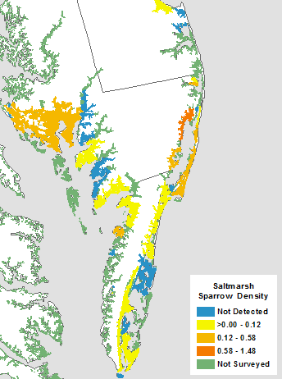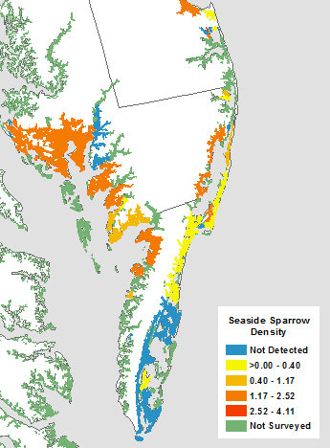

D

C

B

A

Figure 8. The average species densities (birds per ha) during 2011-2012 for tidal marsh specialist birds in marsh patches in Subregions 7 and 8: Coastal Delmarva and Eastern Chesapeake Bay.

Table 1. Historical and ongoing studies with existing marsh bird survey points; studies are listed by organization type, then from north to south. In the Resurveyed column, a ‘Y’ is marked if historical points were resurveyed in 2011 and/or 2012 as part of this research, and an ‘N’ is marked if no points were resurveyed. See Figure 1 for state acronym definitions

|  |  |  |  |
| --- | --- | --- | --- |
| Organization | Historical study | State(s) surveyed | Resurveyed |
| Academic | University of Connecticut | CT | Y |
|  | State University of New York, College of Environmental Science and Forestry | NH, MA, RI, CT | Y |
| State Government | Maine Department of Inland Fisheries and Wildlife | ME | Y |
|  | New Jersey Division of Fish and Wildlife (Rail surveys) | NJ | Y |
|  | New Jersey Division of Fish and Wildlife (Saltmarsh birds) | NJ | Y |
|  | Delaware Department of Natural Resources and Environmental Control | DE | Y |
|  | Maryland Department of Natural Resources | MD | Y |
| Federal Government | U.S. Fish and Wildlife Service (Salt marsh integrity project pilot study) | ME, MA, RI, CT, NY, NJ, DE, VA | Y |
|  | Rachel Carson National Wildlife Refuge | ME | Y |
|  | Parker River National Wildlife Refuge | MA | Y |
|  | Monomoy National Wildlife Refuge | MA | Y |
|  | Bombay Hook National Wildlife Refuge | DE | Y |
|  | Smithsonian Migratory Bird Center (DeLuca) | VA | N |
|  | Smithsonian Migratory Bird Center (Greenberg) | DE | Y |
| Non-Governmental | New Hampshire Audubon (Hampton) | NH | Y |
| Massachusetts Audubon | MA | Y |
|  | New Jersey Audubon (Gateway) | NJ | Y |
|  | New Jersey Audubon (Raritan) | NJ | N |
|  | New Jersey Audubon (Meadow) | NJ | Y |
|  | New Jersey Audubon (Peters) | NJ | Y |

Table 2. Subregions used for sampling stratification, and summary statistics of the sampling universe (number of hexagons [*n*] and marsh area [hectares]) and sampled area (number of sampled hexagons [*n*], marsh area [hectares], and number of survey points [*n*]). Subregion boundaries were developed based on suggestions by Conway and Droege (2006; also see Figure 1 for subregion map and state acronym definitions).

|  |  |  | Sampling universe | | Sampled area | | |
| --- | --- | --- | --- | --- | --- | --- | --- |
| Subregion | State(s) | Boundaries | Hexagons | Marsh area | Hexagons | Marsh area | Survey points |
| 1 Coastal Maine | ME | Lubec, ME to north side Casco Bay, ME | 208 | 6,223 | 43 | 2,573 | 244 |
| 2 Cape Cod - Casco Bay | ME/NH/MA | Casco Bay, ME to Cape Cod, MA (incl. north side U.S. Rt. 6) | 113 | 20,472 | 44 | 10,826 | 340 |
| 3 Southern New England | MA/RI/CT/NY | South of Cape Cod, MA (incl. south side U.S. Rt. 6) to Hudson River, NY | 180 | 10,127 | 35 | 4,005 | 205 |
| 4 Long Island | NY | Long Island, NY | 107 | 9,920 | 31 | 6,263 | 119 |
| 5 Coastal New Jersey | NY/NJ | Staten Island, NY; NJ Meadowlands to Cape May, NJ (oceanside) | 109 | 50,354 | 43 | 32,977 | 293 |
| 6 Delaware Bay | NJ/DE | Cape May, NJ (bayside) to Lewes, DE (bayside) | 88 | 59,956 | 23 | 24,444 | 153 |
| 7 Coastal Delmarva | DE/MD/VA | Lewes, DE (oceanside) to Fisherman Island NWR, VA | 93 | 45,333 | 36 | 25,683 | 241 |
| 8 Eastern Chesapeake Bay | MD/VA | Chesapeake Bay coast east of Susquehanna River mouth | 212 | 78,337 | 22 | 28,272 | 185 |
| 9 Western Chesapeake Bay | MD/VA | Chesapeake Bay coast west of Susquehanna River mouth | 311 | 35,409 | 0 | 0 | 0 |

Table 3. Mean percent occurrence (± SE %) of tidal marsh specialist bird species during the breeding season, 2011-12, by subregion (north to south). Percent occurrence is the percent of survey points where one or more individuals of a given species was detected at 0-50 m during the 5-minute passive point count across all survey visits.

|  |  |  |  |  |  |  |  |  |
| --- | --- | --- | --- | --- | --- | --- | --- | --- |
|  | Subregion | | | | | | | |
| Species | 1  Coastal Maine | 2  Cape Cod - Casco Bay | 3  Southern New England | 4  Long Island | 5  Coastal New Jersey | 6  Delaware Bay | 7  Coastal Delmarva | 8  Eastern Chesapeake Bay |
| Clapper Rail | NA | NA | 2 (1) | 11 (3) | 22 (7) | 25 (12) | 49 (5) | 22 (3) |
| Willet | 3 (2) | 17 (1) | 20 (1) | 34 (4) | 23 (7) | 23 (7) | 39 (1) | 13 (1) |
| Nelson’s Sparrow | 34 (1) | 10 (2) | NA | NA | NA | NA | NA | NA |
| Saltmarsh Sparrow | 2 (2) | 15 (4) | 26 (1) | 15 (1) | 18 (11) | 9 (5) | 16 (1) | 8 (0) |
| Seaside Sparrow | NA | 1 (0) | 5 (0) | 19 (5) | 31 (13) | 45 (11) | 28 (1) | 64 (6) |

Table 4. The total number of saltmarsh habitat patches (*n*) in the Northeast USA and the sampled area, and summary statistics for tidal marsh specialist birds during the breeding season, 2011-12, by subregion (north to south) and region-wide. Species summary statistics were calculated using surveyed marsh patches with species density estimates ≥0.01 birds per ha and include: number of patches detected (*n*) with the percent of these patches relative to the number of sampled patches in parentheses (%); area of detected patches (hectares); and species estimated abundance (number of birds) with 95% confidence intervals in parentheses.

|  | Subregion | | | | | | | |  |
| --- | --- | --- | --- | --- | --- | --- | --- | --- | --- |
|  | 1  Coastal  Maine | 2  Cape Cod - Casco Bay | 3  Southern  New England | 4  Long  Island | 5  Coastal  New Jersey | 6  Delaware  Bay | 7  Coastal Delmarva | 8  Eastern Ches. Bay | Northeast  USA |
| Northeast patches | 1,441 | 536 | 1,201 | 716 | 533 | 166 | 471 | 3,341 | 13,332a |
| Sampled patches | 142b | 109c | 133d | 69 | 63 | 14 | 31 | 21 | 582e |
| Clapper Rail |  |  |  |  |  |  |  |  |  |
| No. patches detected | NA | NA | 4 (7%) | 14 (20%) | 26 (41%) | 10 (71%) | 25 (81%) | 12 (57%) | 91 (36%) |
| Area of patches |  |  | 513 | 1,714 | 38,071 | 53,084 | 36,712 | 52,535 | 182,627 |
| Estimated abundance (95% CI) |  |  | 86  (±63) | 783  (±436) | 22,142  (±11,896) | 22,450  (±12,425) | 31,303  (±11,346) | 24,021  (±14,330) | 106,814  (±24,428) |
| Willet |  |  |  |  |  |  |  |  |  |
| No. patches detected | 5 (4%) | 23 (21%) | 43 (32%) | 31 (45%) | 24 (38%) | 6 (43%) | 25 (81%) | 8 (38%) | 165 (28%) |
| Area of patches | 351 | 13,443 | 1,954 | 2,628 | 37,874 | 52,444 | 35,622 | 47,441 | 191,757 |
| Estimated abundance (95% CI) | 237  (±317) | 4,878  (±1,732) | 2,021  (±661) | 3,117  (±877) | 30,065  (±11,877) | 32,374  (±15,519) | 25,682  (±7,307) | 13,942  (±10,857) | 158,152  (±24,453) |
| Nelson’s Sparrow |  |  |  |  |  |  |  |  |  |
| No. patches detected | 44 (31%) | 13 (25%) | NA | NA | NA | NA | NA | NA | 57 (30%) |
| Area of patches | 1,747 | 3,955 |  |  |  |  |  |  | 5,701 |
| Estimated abundance (95% CI) | 1,887  (±445) | 1,893  (±962) |  |  |  |  |  |  | 5,376  (±1,209) |
| Saltmarsh Sparrow |  |  |  |  |  |  |  |  |  |
| No. patches detected | 6 (9%) | 26 (24%) | 52 (39%) | 65 (94%) | 18 (29%) | 4 (29%) | 16 (52%) | 5 (24%) | 192 (38%) |
| Area of patches | 492 | 12,679 | 2,628 | 3,484 | 36,449 | 40,005 | 26,252 | 45,851 | 167,841 |
| Estimated abundance (95% CI) | 85  (±113) | 6,355  (±2,509) | 1,907  (±650) | 1,144  (±483) | 19,167  (±9,000) | 3,485  (±2,035) | 6,992  (±2,935) | 4,866  (±4,929) | 76,712  (±15,330) |
| Seaside Sparrow |  |  |  |  |  |  |  |  |  |
| No. patches detected | NA | 2 (3%) | 10 (8%) | 20 (29%) | 24 (38%) | 7 (50%) | 18 (58%) | 11 (52%) | 92 (24%) |
| Area of patches |  | 1,326 | 867 | 1,980 | 38,683 | 52,520 | 17,074 | 51,076 | 163,527 |
| Estimated abundance (95% CI) |  | 178  (±426) | 376  (±342) | 923  (±566) | 31,808  (±14,781) | 67,867  (±39,513) | 22,312  (±10,743) | 60,681  (±19,582) | 140,952  (±30,785) |

a Total patches defined in Subregion 9: Western Chesapeake Bay (*n* = 4,927) are not included in the table, but are included in the total.

b *n* = 69 for Saltmarsh Sparrow.

c *n* = 51 for Nelson’s Sparrow and *n* = 59 for Seaside Sparrow.

d *n* = 57 for Clapper Rail.

e *n* = 255 for Clapper Rail, *n* = 193 for Nelson’s Sparrow, *n* = 509 for Saltmarsh Sparrow, and *n* = 390 for Seaside Sparrow.